INTEGRATING THE KANO-MARADI RAILWAY WITH THE AFRICAN INTEGRATED STANDARD GAUGE RAILWAY NETWORK (AISGRN).
By Rowland Ataguba

It is generally a moot point that the involvement of the African Development Bank (AfDB) in the funding of the Kano-Maradi SGR would have no bearing on the putative unbundling of the Nigerian Railway Corporation (NRC). It is however the case that unbundling the NRC will open up the railway space to broader and more intelligent investment and this is what the presence of the AfDB in the funding line up may portend.
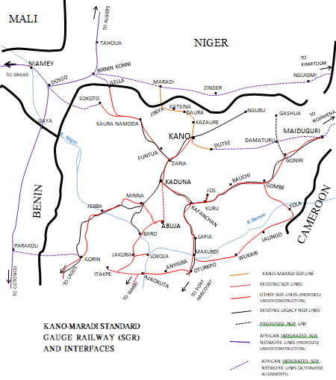

The Kano-Maradi SGR is a $1.9bn contract awarded to Mota Engil basis EPC+F (Engineering, Procurement and Construction plus Financing) in 2021 for 4 years. So, the AfDB’s reported $350m lending putatively amounts to some 20% of the infrastructure capex. The reality though appears to be that a total of about $1.8bn has been sourced from the AfDB and its partners comprising African Finance Corporation (AFC), African Exim Bank (Afrexim) and Chinese insurer Sinosure to cover the cost of the infrastructure.

Recall that a bridging loan was obtained by MOFI (Ministry of Finance Incorporated) in 2022 to kick start construction, a new challenge may be how to quickly access the new funds to forestall the ongoing works coming to an albeit temporary halt and the disruption and added costs this would bring. Whereas the original funding strategy did not envisage government counterpart funding, this is now unlikely to be the case given MOFI’s involvement.

What may confound however is that construction commenced in 2022 without a credible funding plan and the project appears to have careered from one unfulfilled promise to the next. It is a no brainer that the Public Procurement Act makes it criminal to award a contract without a clear funding plan, but successive governments have repeatedly flouted this proviso. Considering that these contracts are approved at the highest levels of government, it speaks to the impunity that has characterized our modern public procurement process. It is also unfortunate that we have ended up spending forever to construct the Lagos-Kano SGR which was contracted in 2006 for 4 years. Without this line, Kano-Maradi will remain commercially inchoate. This is important as the Kano-Maradi line requires access to the sea to make business sense considering that Niger republic is landlocked and given that the LAKAJI corridor is one of the most studied trade corridors in Nigeria. A corridor with estimated 50m-100m ton movements per annum hauling agricultural and mineral resources as well as manufactures and people.

As a competing rail line will run from Niamey to Cotonou port in neighbouring Benin Republic, Nigeria cannot afford to be complacent due to the competing interests for port access. It may however be fortuitous that the Niamey–Cotonou railway is currently bogged down in dispute between two contending contractors, Bollore and Petrolin. The Beninois government may have further complicated an already complex situation by awarding the same contract that is in dispute to the Chinese. Notwithstanding, when the Dakar to Khartoum east-west beltway of the African Integrated SGR network eventually comes on stream, other corridors could open port access for Niger republic such as the ports at Abidjan, Cote d’Ivoire, Lome, Togo and Tema, Ghana, so Nigeria must sit up and get its act together.

Nevertheless, connecting any of the 3 candidate Nigerian ports of Lagos, Warri or Port Harcourt to Kaduna by SGR may be many years away still. Other hold ups include completion of Kaduna-Kano SGR which has been struggling along for some years and is yet to be completed. Perhaps the biggest elephant in the room is Ibadan-Abuja SGR which is yet to be instructed due to funding challenges. In a nutshell, this Kano-Maradi SGR line is unlikely to achieve business viability until a number of other contracts are completed and they appear to be at least some 5 years away. This of course assumes frantic efforts are being made to bring them to fruition and I daresay that our approach on relying on the Federal Government alone to build rail infrastructure is fraught with challenges.

It is indeed disappointing that the Lagos-Kano SGR which should have been completed in 2010 can only now be hoped to be completed perhaps in 2030, which is 20 years late! While this is not a death sentence as there are many big infrastructure projects across the world that have come in late, over budget and yet became successful. The channel tunnel (Eurotunnel) between Dover and Calais linking the UK to France is one of such. Unconscionably is the rising cost of the Lagos-Kano SGR thanks to the machinations of our political classes beginning with the intervention of late President Umar Yar Adua and his governor colleagues in 2008 which effectively derailed this project from which it is apparently yet to recover.

The strategic imperative of this Kano-Maradi line is that it is part of the LAKAJI (Lagos-Kano-Jibiya) corridor which should ordinarily integrate with other networks to constitute the African integrated SGR network. This rail network should be a fundamental infrastructure pillar of the African Continental Free Trade Area (AfCFTA). The Kano-Maradi railway line would however appear to lie outside the Algiers- Abuja-Lagos railway alignment which is a north-south beltway of the AISGRN, that integrates with the Dakar-Bamako-Ouagadougou-Niamey-Ndjamena-Khartoum line, an east-west beltway which are components of the AU's Agenda 2063. This is why the AfDB’s interest in the project comes as no surprise though it is yet to translate into instigating strategic coherence. The further strategic concern is how this line will be operated, and this is why recent developments including the putative NRC unbundling excites interest and is significant.

Now, there are two masterplans in play. The ECOWAS masterplan which predates the AU Agenda 2063 masterplan which is the other, both being expected to integrate and synergize. Whereas the ECOWAS plan includes the Kano-Maradi railway, the AU plan doesn’t. Curiously enough, the ECOWAS plan contains what would appear to be a gap in national railway contiguity. For instance, travel by rail from Maradi to Dosso or Niamey, all within the same country (Niger republic) would involve going through Nigeria, a third country. Whereas the AU plan has the Algiers-Abuja-Lagos railway (a north-south beltway) coming into Nigeria from Algeria through Tahoua in Niger and Birnin-Konni. It then enters Nigeria through Ilella, Kaura Namoda and Zaria to Abuja and Lagos on a new standard gauge alignment of which only Abuja-Kaduna has been completed and in effect bypasses the Kano-Maradi line. An alternative alignment may come through Dosso to Sokoto travelling through Kaura Namoda, Funtua to meet the Kano-Kaduna line at Zaria.
Now, any realistic examination of the competitive environment would require that the ECOWAS community be a completely customs and barrier free zone permitting the free movement of people and goods. The same applies for the AISGRN. Were a passenger or freight train be required to clear customs at every international border, what should have been movements taking hours would take days. This would have serious implications for the AfCFTA (African Continental Free Trade Area). A movement from say Niamey to Maradi within Niger Republic, travelling through Nigeria should therefore not cause concern any more than a train or truck freight movement in the EU requiring passage through a “second country” for expedient delivery to a destination in the originating country. These types of situations are typically the result of geography or history. There are similar border situations between Canada and the USA where a freight train from Detroit, Michigan to Buffalo, New York would travel through Canada. There is also a similar situation involving India and Bangladesh where the least expensive way to move freight between Kolkata in India and Assam, an eastern Indian province, would be through Bangladesh.

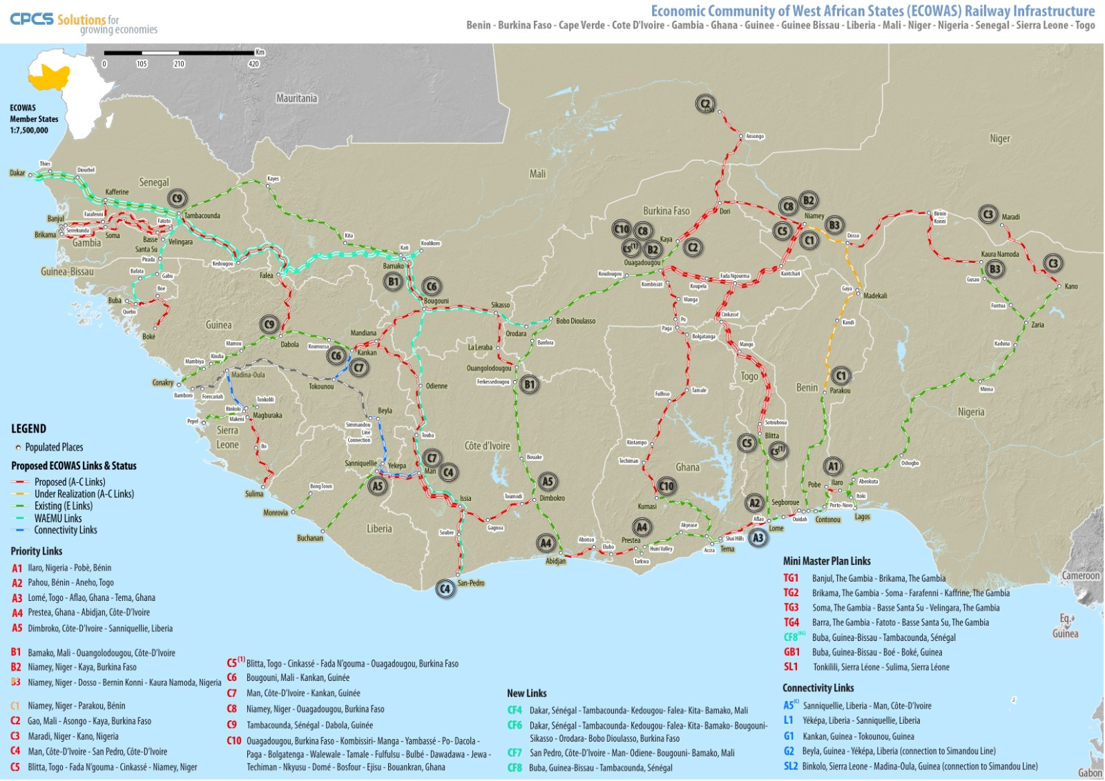

THE ECOWAS RAIL MASTERPLAN

History would suggest that the colonial powers designed their railways to exploit resources in their colonies and other considerations were secondary. Hence the implication that today the least expensive way to join Niamey and Maradi by rail would be through the use of Nigeria’s rail system should not surprise at least from a business perspective. Such a movement would obviate the need to spend hundreds of millions of dollars in new rail construction of questionable economic value.

An interesting point to note is the separate contract for the supply of rolling stock by the constructor Mota Engil for nearly $1bn. While the breakdown of equipment to be supplied has not been publicly disclosed, it portends a sizeable contingent. So, who will operate the line? Would it be the NRC as is, or the NRC unbundled operator successor? Would Mota-Engil be tasked to put together an operator SPV as we have allegedly done with the Chinese on Lagos-Ibadan? Such arrangements can only be a stop gap as these companies are constructors not operators and may not have an enduring capacity for rail operations. A more credible approach would be to conduct a transparent international and competitive tender for operations and maintenance concessions which would have far reaching consequences for the sustainability of the railway.

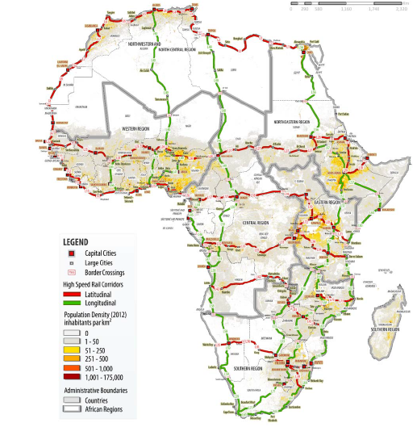

THE AFRICAN INTEGRATED STANDARD GAUGE RAILWAY NETWORK (AISGRN)

The news of the recent operator’s licence issued to CCECC (on Lagos-Ibadan) and the arrangements with LAMATA on the ROW (right of way) in the Ebute Metta - Alagbado corridor (Red line) may suggest that the NRC may be relaxing its covetous grip on railway operations, but the licences beg more questions about the criteria adopted in assessments, the opacity of the process and the timing. It would also appear that these emergent operators have been running trains for nearly a year without these licences. With the LAKAJI corridor as providing the most financially viable freight corridor in Nigeria, it is no surprise that CCECC has quickly pitched its tent there.

Recall that the concession of the Ibadan dry port was awarded to CCECC/CRCC and may inform a track access agreement with the NRC though the dry port is yet to be built. CCECC has also built a wagon assembly plant in Kajola which it gifted the FG as corporate social responsibility. The standard gauge wagons from this plant will certainly find utility in moving containers from Apapa to Ibadan for the CCECC dry port operations. The tenor of the licences could however raise immediate concerns as they may discourage investment in assets that would outlive the licence terms. Notwithstanding, these licences flag up the inadequacy of the existing NRC Act and point to the need for urgent NRC unbundling to create an independent regulator in the least.

In simple terms, under the existing Act, a dispute between the parties can only be resolved by the NRC as regulator creating a clear conflict of interest. International companies such as these may typically resort to costly international arbitration and if we know one thing about how our government agencies have historically conducted business, a costly breach of contract in the future by NRC would surprise no one.

In the northern axis, there is the potential for freight and passenger movements between Maradi, Katsina, Kano, Dutse, Kaduna and Abuja on the SGR. Transfers to the Lagos-Kano narrow gauge railway may take place at Rigachikun or Kaduna Junction in theory but all dependent on whether a well-resourced and customer focused operator is running the railway. All of which would depend on the completion of several outstanding projects as outlined above. There is of course, the central line gap between Itakpe and Abuja to be bridged, and the Warri port to be re-energised or a deep seaport perhaps built at Escravos. Then there are the Port Harcourt to Maiduguri narrow gauge rehabilitation and reconstruction contract as well as the Coastal railway between Lagos and Calabar.

Most of these projects which may have been procured on a single source basis have been struggling to find funding and may need to be better procured in a transparent and competitive manner to be able to attract the kind of funding that can deliver them. It is only in this sort of environment of renewed integrity that the projects can be completed and deliver value for money.

The integration of Kano-Maradi with the African SGR network is multifaceted. First is that the east-west beltway from Dakar to Sudan would meet the Algiers-Lagos north-south beltway at Birnin Konni in Niger republic and enter Nigeria at Illela in the north west. An alternative alignment may however come through Dosso to Sokoto on to Kaura Namoda, Funtua to meet the Kano-Kaduna line at Zaria. It would then travel eastwards to Maiduguri through Kano, Dutse and Damaturu to cross the border into Ndjamena, Chad, and on to Khartoum, Sudan. Second is in southern Nigeria.

Another east-west beltway comes from Cairo and travels along the coast through Tunis, Algiers, Casablanca, Dakar, Conakry, Bissau, Abidjan, Accra/Tema, Lome, Cotonou to Lagos. This crosses Nigeria on the coastal railway from Lagos to Calabar and across the border to Yaounde, Cameroon, from where it goes into the Central Africa Republic (CAR) and connects Democratic Republic of the Congo (DRC), Rwanda, Uganda and Kenya. If and when these links are completed and assuming Nigeria faithfully completes its rail projects, traffic can flow from Maradi into any of the Nigerian ports of Lagos, Warri or Port Harcourt. It can also travel through the Dakar-Sudan east-west beltway to any of the ECOWAS countries or to east and central Africa. Pertinently all of this traffic would transit through Nigeria. An alternative alignment to connect Maradi to the African SGR will be to link Birnin Konni to it and travel eastwards through Zinder to Ngugmi and across the border into Chad. It is however debatable if the resources can be found to build such a line on account of its financial viability, leaving the alignment through Nigeria as the only feasible option.

A key challenge that the Kano-Maradi railway faces is political, and it is the decision by Niger Republic alongside Burkina Faso and Mali to exit the ECOWAS community. So, notwithstanding ECOWAS’ best intentions, the entire ECOWAS experiment may be just that, an experiment which may be in its death throes. Should that be the case, only the good Lord himself would be able to evaluate the economics and operational parameters of a bonded train service between Niamey and Maradi through Nigeria. Notwithstanding, whether in or out of the ECOWAS, Niger republic needs access to the sea and to trade with its neighbours and cousins in Nigeria. So, a customs union with Nigeria may be in both countries’ enlightened self-interest though such would have been easier achieved with Niger rep. inside of ECOWAS. Whereas there has been much sabre rattling by Niger about port access via Algeria, which is non-ECOWAS, and as this is part of the AU’s Agenda 2063, it may offer a challenge and opportunity to Nigeria in other ways.

In a nutshell, the Kano-Maradi line if completed will have limited utility with only movements between the market towns of Maradi and Kano city as well as Dutse. But bring in Kano-Kaduna into the mix and you can run trains all the way to Abuja which improves the viability though not quite at a decent EIRR (Economic Internal Rate of Return). The sea port link to Lagos may come from transhipment at Rigachikun when built as part of the Port Harcourt–Maiduguri narrow gauge contract. A contract that is also bogged down with funding challenges, achieving less than 10% completion after three years of four. So, if this contract is completed, two ports immediately come into view (Lagos and Port Harcourt) though transhipment costs could erode financial viability unless sufficient traffic can be ramped up. Notwithstanding, building the Ibadan-Abuja SGR would obviate the need for costly transhipment.

Finally, the fixed infrastructure when completed cannot operate itself. The NRC as currently structured remains a poor advertisement for a railway operator. Unless it is unbundled to separate regulation from operations so that private investors can run railway operations independently, separate policy making from policy implementation and even rail freight from passenger rail, we may only succeed in building railway infrastructure which end up dilapidating after a few years if history is anything to go by. This is not to say that Nigeria’s neighbours are doing much better with their railway commitments under AU Agenda 2063 but there are glimmers of hope. Morrocco, Egypt, Tanzania have blazed the trail while Kenya, Ethiopia and others are making slow progress too. Nigeria, Ghana and a many others may be struggling with theirs. The AUDA which is the AU’s coordinating agency for the Agenda 2063 needs to do more to help countries meet their commitments so that a truly integrated network of networks can emerge in Africa. Do this and Africa especially Nigeria will be unstoppable. Importantly, it can be done.

** Rowland Ocholi Ataguba is a London based strategic railway delivery expert. CEO of Bethlehem Rail Infrastructure Limited, he is a member of the NRC Unbundling Committee and author of the memorandum that initiated the constitution amendment transferring Railways from the Exclusive to the Concurrent list. Chairman of the Technical Advisory Committee (TAC) on the Railway Bill and National Transport Commission Bill in the House of Representatives. A major contributor to the debate on the place of railways in national development, he is author of many policy papers including publishing the epic "Modelling the Nigerian Railways".

