Enhancing Railcar Safety and Longevity with Advanced Impact Analytics: The RailBlazer Advantage

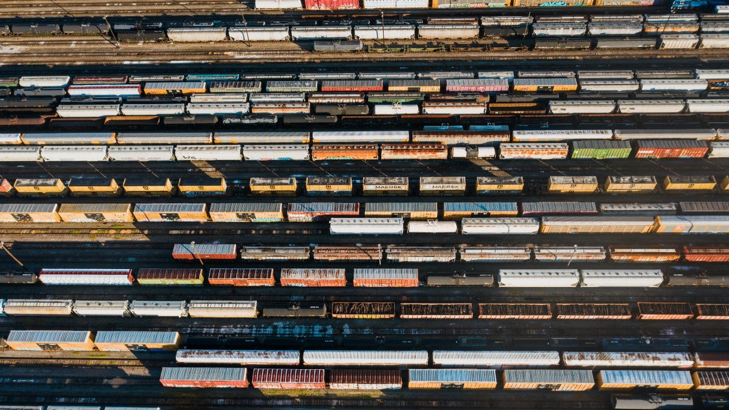
Efficient railcar operations hinge on precise health monitoring, particularly during loading/unloading processes and train makeup coupling procedures in classification yards.
Impact force measurements, particularly during coupling operations, provide critical insights into stress distributions across railcar structures and components.
According to the FRA's Impact Performance of Draft Gears study, soft draft gears - which degrade over time - permit greater stress concentrations and higher coupler forces, especially at elevated impact speeds. This deterioration significantly increases the risk of structural damage, such as stub sill cracking or separation, which can result in derailments and, in the case of tank cars, hazardous material spills.
On the other hand, prime draft gears are more effective at reducing impact forces and protecting railcar integrity, even under extreme conditions like 286,000-pound gross rail load operations.
The research highlights the importance of integrating advanced impact measurement systems with finite element modelling to detect vulnerable areas early, guide preventive maintenance, and optimize draft gear performance across varying operational speeds.
These measures are essential for reducing accidents and ensuring the safety and reliability of rail freight operations.
Trilogical’s RailBlazer railcar telematics system introduces an innovative approach to impact analysis, offering railcar manufacturing & leasing companies and railcar fleet owners the tools they need to mitigate damage risks, reduce maintenance costs, and extend the lifecycle of their assets. At the heart of this solution is highly accurate impact monitoring, enabled by a combination of precise timely measurements and advanced analytics. Let’s dive into how RailBlazer transforms railcar management and safety.

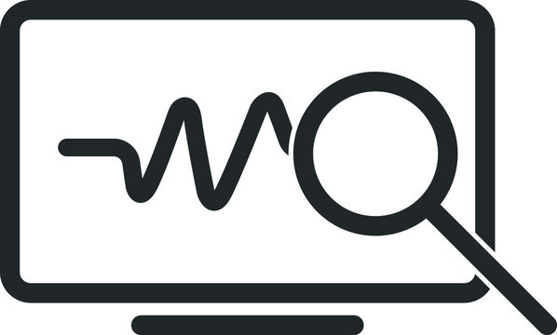

Critical Risks Addressed by RailBlazer
Impact and vibration analysis are essential for ensuring safety by providing precise insights into operational events. With its advanced impact and vibration monitoring capabilities, RailBlazer allows identifying and mitigating a range of risks, including:
- Damage to railcar body during the coupling process.
- Railcar and cargo damage during loading and unloading operations.
- Flat wheel or brake issues during transit.
- Derailment risks that could disrupt operations or compromise safety.
Additionally, the system delivers highly accurate timing monitoring of the loading and unloading processes, offering users better operational insights and enabling enhanced safety measures.

The Golden 50 Milliseconds Principle: Capturing the Critical Data
Impact events, such as hard couplings or excessive force during loading, typically occur within a fleeting 200-300 milliseconds. Capturing these moments is vital for identifying and addressing potential damage.
RailBlazer’s advanced 3-axis accelerometer sensor wakes from its low-power "hibernation" mode in just 50 milliseconds, ensuring it captures the peak of every event. Within 100 additional milliseconds, the system processes the data, balancing speed, precision, and energy efficiency to deliver actionable insights without compromising battery life.

Comprehensive Impact Event Analysis
The RailBlazer system doesn’t just capture impact data - it turns it into actionable intelligence. By integrating vibration data with additional operational factors, the system enables the identification of repeated risky events that could compromise safety, reduce the railcar’s lifespan, or lead to hazardous situations requiring immediate inspection.
Key parameters analysed include:
- Impact directions (axis) to understand the forces applied.
- Geographical location within loading, unloading, or transit zones.
- Railcar speed to contextualize the event.
- Railcar status (loaded, empty, or partially loaded).
- KIPS calculations, representing force adjusted for railcar load.
- Repetition and frequency of events to detect patterns.

Key Benefits of Advanced Impact Monitoring
RailBlazer empowers railcar manufacturing & leasing companies, railcar fleet owners as well as railroads with three critical advantages:
- Early detection of recurring excessive impacts during loading and unloading, reducing long-term wear and tear.
- Immediate derailment alerts, ensuring swift responses to high-risk events.
- Tailored recommendations for railcar inspections based on KIPS thresholds, enhancing proactive maintenance and safety.
This advanced analysis ensures timely responses to potential risks, improving operational safety while extending the service life of railcars.

From Detection to Decision: Intelligent Edge Analysis
Once an impact event is detected, RailBlazer leverages its onboard intelligence to analyse the data instantly. Key parameters - such as speed, location, load status, and force intensity - are evaluated to determine whether the event warrants further action. If necessary, the system:
- Activates its full suite of sensors.
- Sends real-time alerts to operators via the RailBlazer platform.
- Provides detailed data to guide immediate or scheduled maintenance.
This autonomous edge analysis ensures railcars are treated proactively, reducing downtime and repair costs.

Decoding the Data: Insights at Your Fingertips
RailBlazer doesn’t just collect data - it transforms it into actionable insights through its user-friendly application. Railcar manufacturing & leasing companies and railcar fleet owners can visualize and analyse impact events across several dimensions:
- Vibration Graphs: to reveal the exact nature of impacts.
- Event Details: Metrics such as KIPS (calculated force based on load status), G-forces, speed, and location help users understand the severity of each event.
- Historical Trends: A log of past events allows comparison and identification of patterns, distinguishing isolated incidents from recurring risks.
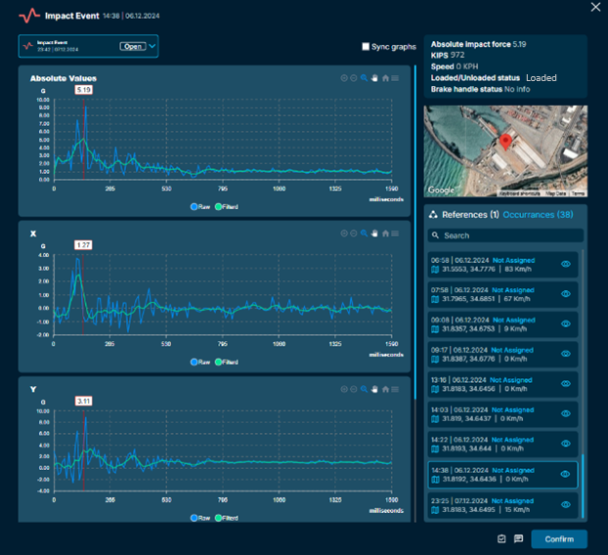
By integrating this data, RailBlazer empowers railcar fleet managers to take informed actions, such as scheduling inspections, implementing operational changes, or even halting operations in critical scenarios.

Why it Matters: Protecting Your Investment
Railcar manufacturing & leasing companies and railcar fleet owners face unique challenges in maintaining their fleets. Excessive impacts during loading or coupling can lead to:
- Structural damage to railcar bodies.
- Cargo losses and Safety Risks during transit.
- Costly repairs and reduced operational lifespan.
RailBlazer minimizes these risks by combining precision monitoring with intelligent analytics. The system detects abnormal impacts, triggers alerts, and even recommends inspections based on exceedance of critical thresholds, such as the 800 KIPS limit.

A Smarter Future for Railcar Management
RailBlazer’s ability to monitor, analyse, and act on impact data sets a new standard in railcar management. With its intelligent design and actionable insights, railcar manufacturing & leasing companies and railcar fleet owners can significantly reduce maintenance costs, improve safety, and extend the service cycles of their fleets.
Adopting RailBlazer technology is an investment in the future of efficient and sustainable railcar operations.

About Trilogical Technologies:
With over 25 years of IoT expertise in aviation, defence, HLS, and logistics, coupled with 15 years of specialized experience in the Railway industry, Trilogical Technologies is a prominent player in Remote Condition Monitoring, Diagnostics and Asset Management serving railroads, fleet owners, and shippers. Trilogical monitors thousands of mobile assets across extensive projects in the Middle East, Asia, and Africa.

Issued by:
Trilogical Technologies Ltd.
Tatiana Voloshin - Int. Business Development Director
Mobile: +972-52-8797588
Email: tatianav@trilogical.com
LinkedIn: https://www.linkedin.com/company/trilogical-technologies-ltd
@ Trilogical Technologies Ltd

