Insights into Uganda Railways Corporation's Projects and Regional Connectivity
Speaking at the African Union Commission (AUC)’s Department of Infrastructure and Energy (IED) Continental Workshop on the Implementation of the Africa Integrated Railways Network (AIRN), held in May 2024, in Dar es Salaam, Tanzania, Jesca Bakazibazira, Senior Commercial Officer at Uganda Railways Corporation (URC), provided insight into URC's railway programme and the regional connectivity projects.
In her address, Bakazibazira detailed the history, business segments, railway corridors, ongoing and recent projects, future projects, and key interventions of URC. The history of Uganda's railways dates back to when the railway reached Kampala in 1931 and Kasese in 1956. The Uganda Railway was named after its ultimate destination, although its entire original 1,060-kilometre (660-mile) length lies in present-day Kenya. Construction began at the port city of Mombasa in British East Africa in 1896 and finished at the line's terminus, Kisumu, on the eastern shore of Lake Victoria in 1901. The metre gauge railway (MGR) network in Uganda was mostly laid out between the 1920s and 1960s to link the interior of Uganda and Kenya with the Indian Ocean port of Mombasa in Kenya. Key milestones include:
- 1926: Jinja
- 1929: Tororo to Soroti
- 1931: Kampala
- 1948: Formation of East African Railways and Harbours Corporation (EARH)
- 1956: Kampala to Kasese
- 1964: Pakwach
- 1977: East African Community (EAC) breakup
- 1992: Uganda Railways Corporation (URC) Act
- 2006-2018: Rift Valley Railways (RVR) concession
- 2018 to date: URC current operations
In 2006, URC entered a concession with Kenya Railways under Rift Valley Railways, which was terminated in 2018, leading to URC resuming operations. Currently, URC operates only 269 kilometres out of its 1,266-kilometre network, with the government working on revamping the non-operational 997 kilometres.
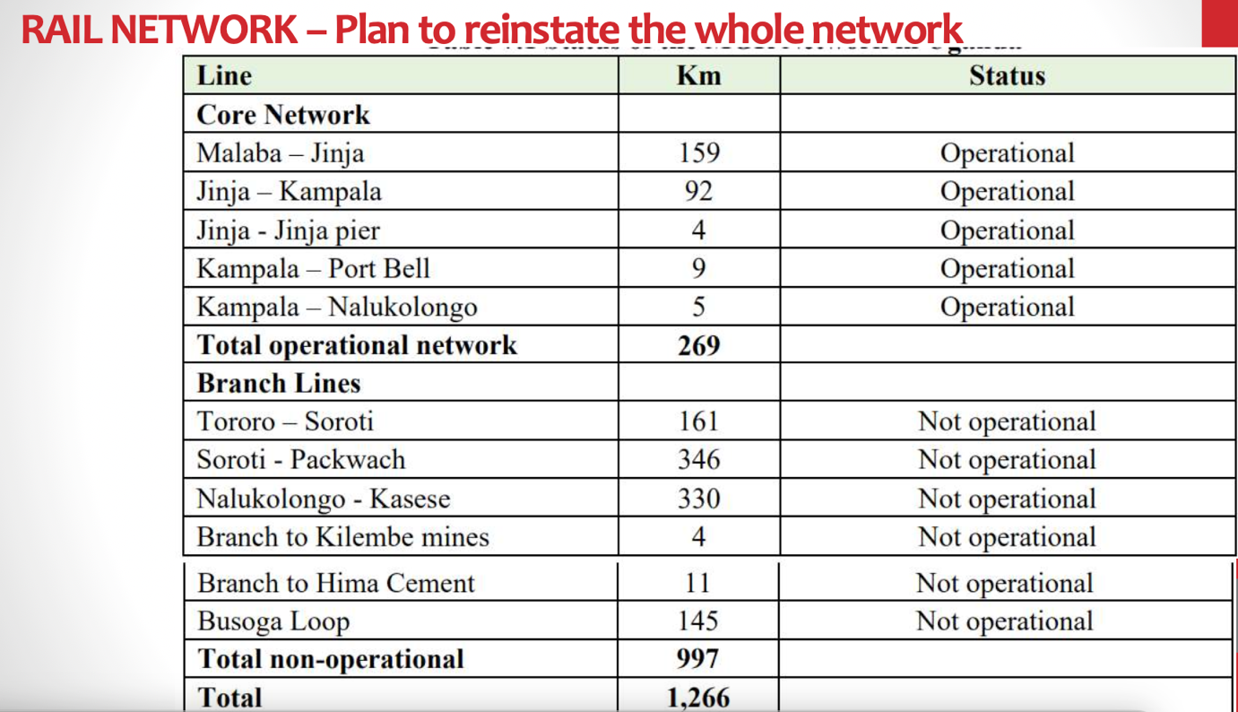
One significant project is the rehabilitation of the Tororo-Gulu line, a 375-kilometre stretch. Bakazibazira highlighted the strategic importance of this line, which is part of Uganda's broader network, including the existing metre gauge railway (MGR) and proposed standard gauge railway (SGR) lines aimed at enhancing connectivity to Rwanda and South Sudan.
URC's business segments encompass freight, passenger services, and marine operations. The railway workshop serves both internal and external needs, and the commuter service currently covers 13 kilometres, with plans to extend to Mukono by June 2024. Marine operations under URC include two roll-on/roll-off rail vessels, MV Pamba and MV Kaawa, which link Uganda with Tanzania through Mwanza Port, Port Bell, and Jinja Pier. This marine connectivity supports cargo movement between Dar es Salaam and Uganda, complementing the railway network.
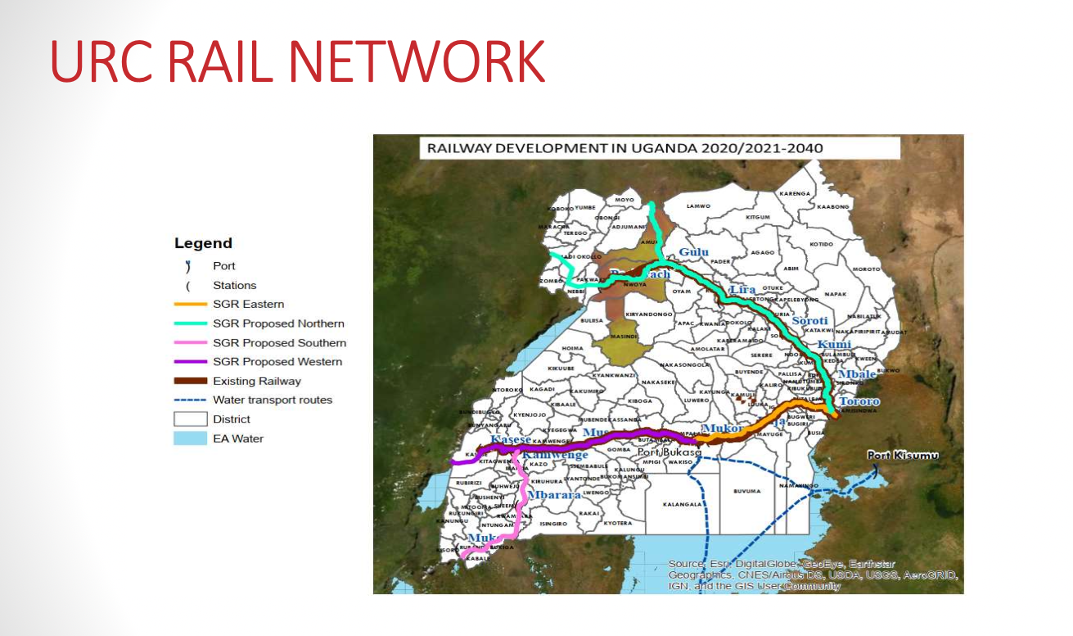
Bakazibazira also mentioned the key logistics hubs under URC, such as the recently completed Gulu Logistics Hub, aimed at serving South Sudan and Eastern Congo. The Mukono Inland Container Depot (ICD) and the Kampala Goods Shed are also crucial nodes in the network. The Central Corridor, primarily through Mwanza, contributes 20% of Uganda's freight tons, with improvements needed to enhance its competitiveness. Five days transit DAR-MZA and 17-18 hours on water. Asset availability ~200 wagons (Rehabilitation of 20 URC flatbed wagons by the Central Corridor Transit Facilitation Agency).
The Northern Corridor, from Mombasa to Kampala, handles the majority of Uganda's freight, utilising both MGR and SGR in Kenya, with an interchange at Naivasha.
Ongoing projects include the rehabilitation of the 375km, Tororo-Gulu MGR line, managed by China Rail and Road Bridge Corporation, supervised by M/STYPSA. This project started in November 2023 and is currently at 30%. Rehabilitation of the Kampala-Mukono line, specifically the upgrade of 43 km of rail track to concrete sleepers, began in March 2023 and is currently at 75% reported progress.
URC is also working on a capacity building and asset improvement project. The URC Capacity Building project, led by Consultrans, aims to enhance the performance of the Uganda Railway Corporation through consultancy services. The project, valued at €25.9 million, is currently in the defects liability period with a weighted physical progress of 80%. Consultrans is facilitating the guaranteed transfer of technology and know-how to improve the Corporation and its future development. The Government of Uganda (GoU) is supporting ongoing capacity building programmes to transform the organisation and train personnel in their respective fields. The project includes a significant human resource component, with capacity building provided by Consultrans SAU.
Future projects focus on expanding and upgrading the network. Plans are in place for the Kampala-Port Bell and Kampala-Kyengera lines to concrete sleepers to support passenger services with funding from the African Development Bank. The AfDB funding is a comprehensive revamp of MGR operations, including the purchase of locomotives, wagons, marine vessels, and institutional development.
Recently, Uganda, Rwanda, and Kenya's ministers committed to advancing the SGR project, starting with the Kampala-Malaba section, with future extensions to Kasese, Mpondwe, and into Rwanda and South Sudan. URC hopes to commence this project within the financial year, contingent on funding availability.
Bakazibazira concluded by emphasising the need for continuous interventions and funding to fully realise URC's goals, ensuring the network's sustainability and effectiveness in the region's broader connectivity framework.
Crucial issues include interoperability between Uganda's railway system and those of its neighbours, Tanzania and Kenya. Uganda is adopting the standards used by Kenya Railways for the Northern Corridor. Recent engagements indicate that the same Chinese company involved in Kenya's SGR projects will be employed. Although there are some funding issues, discussions with Kenya Railways are underway to align Uganda's standards with those of Kenya for the northern part of the network.
For the Central Corridor, development efforts are supported by the African Development Bank to enhance Port Bell. This project will implement the same gauge and standards as Tanzania. The Central Corridor map shows the route originating from Tanzania through Lake Victoria to Port Bell or Jinja Pier, accommodating both Tanzanian and Kenyan railway standards for seamless connectivity.
The railway line from Tororo to Kampala, Tororo to Gulu, and Pakwach to South Sudan will follow the standards of Kenya Railways (KRC), aligning with the Northern Corridor. Currently, for the route from Nairobi to Kampala, cargo moves on standard gauge from Mombasa to Naivasha. At Naivasha, it is transferred from standard gauge to metre gauge, then transported from Naivasha to Malaba, where Uganda takes over the wagons.
This system utilises the SGR to serve customers efficiently. Although there is an interchange at Naivasha, future plans aim to eliminate this, allowing wagons to move directly from Mombasa to Kampala without any need for an interchange. Despite the current arrangement, operations are managed without significant delays, particularly for containerised cargo, which is easier to handle in this manner.

SEO Meta Keywords
Uganda Railways Corporation, URC, African Union Commission, AUC, Department of Infrastructure and Energy, IED, Africa Integrated Railways Network, AIRN, Dar es Salaam, Tanzania, Jesca Bakazibazira, Uganda railway programme, regional connectivity projects, metre gauge railway, MGR, standard gauge railway, SGR, Tororo-Gulu line rehabilitation, freight services, passenger services, marine operations, Gulu Logistics Hub, Mukono Inland Container Depot, ICD, Kampala Goods Shed, Central Corridor, Northern Corridor, China Rail and Road Bridge Corporation, M/STYPSA, Consultrans consultancy, African Development Bank, AfDB, Kampala-Malaba section, interoperability, Port Bell enhancement, seamless connectivity, future railway projects, cargo movement, railway standards, Rift Valley Railways, RVR, Kenya Railways collaboration, Kampala-Port Bell upgrade, Kampala-Kyengera lines upgrade, railway ministers, capacity building, asset improvement project

SEO Meta Page Description
Uganda Railways Corporation railway programme, regional connectivity projects, and future expansions. Topics include metre and standard gauge railways, key infrastructure projects, freight and passenger services, and strategic partnerships with Kenya and Tanzania.

