A new chapter begins for rail transport between Tunisia and Algeria after a three-decade hiatus
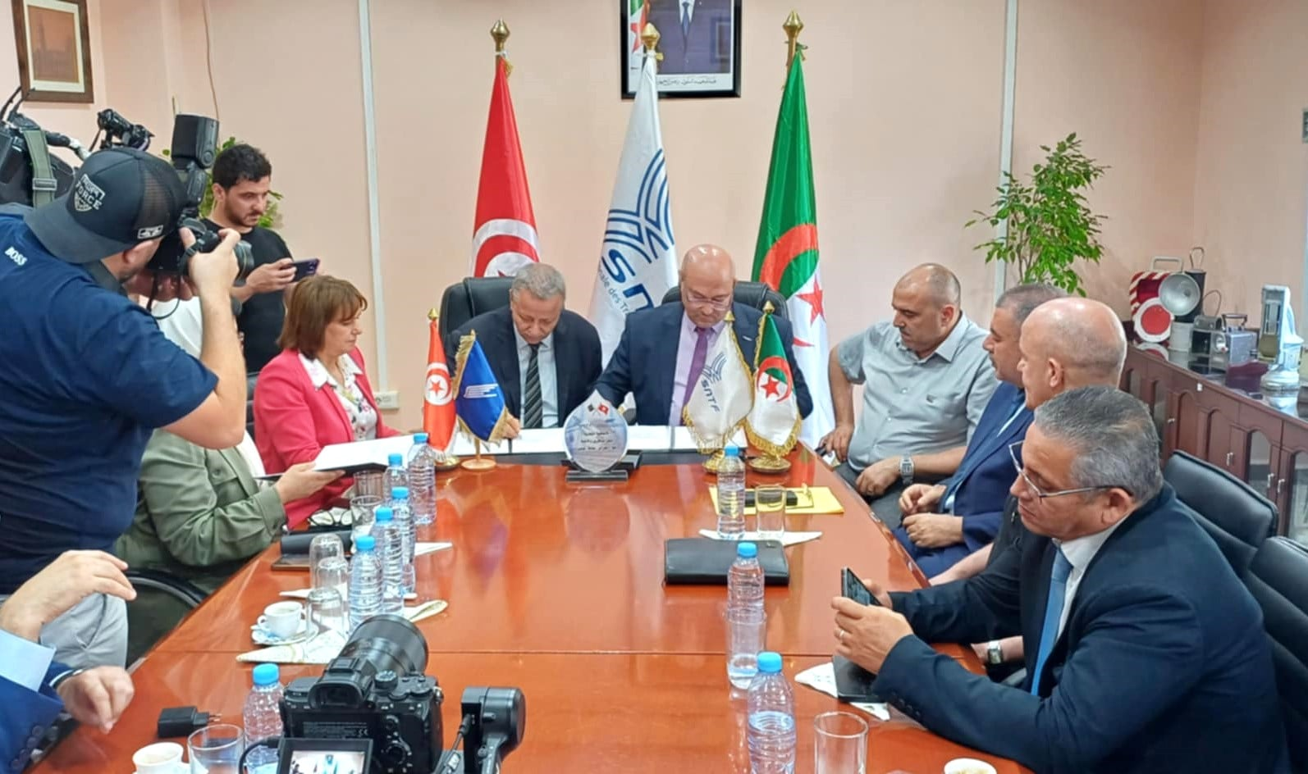
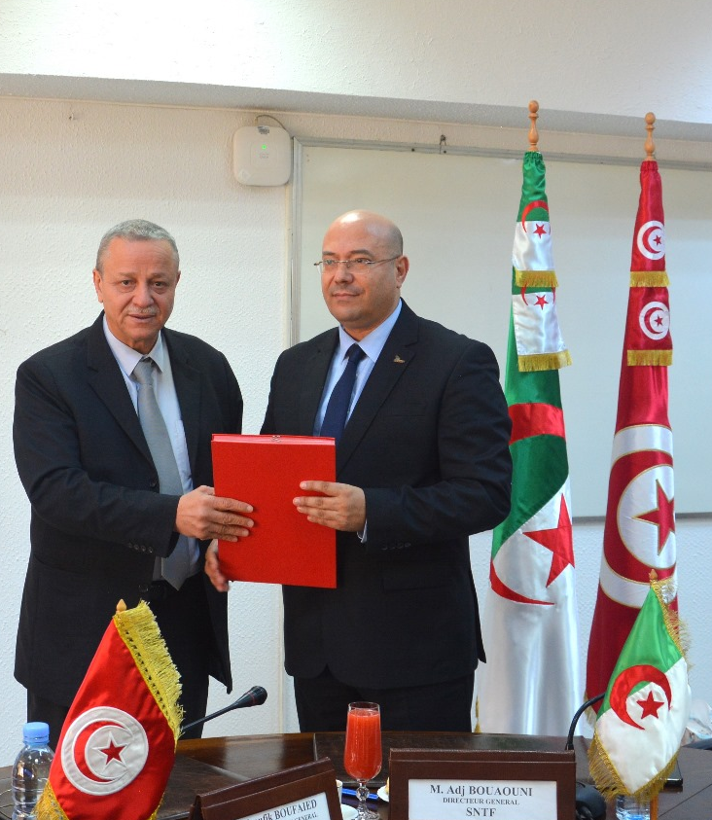
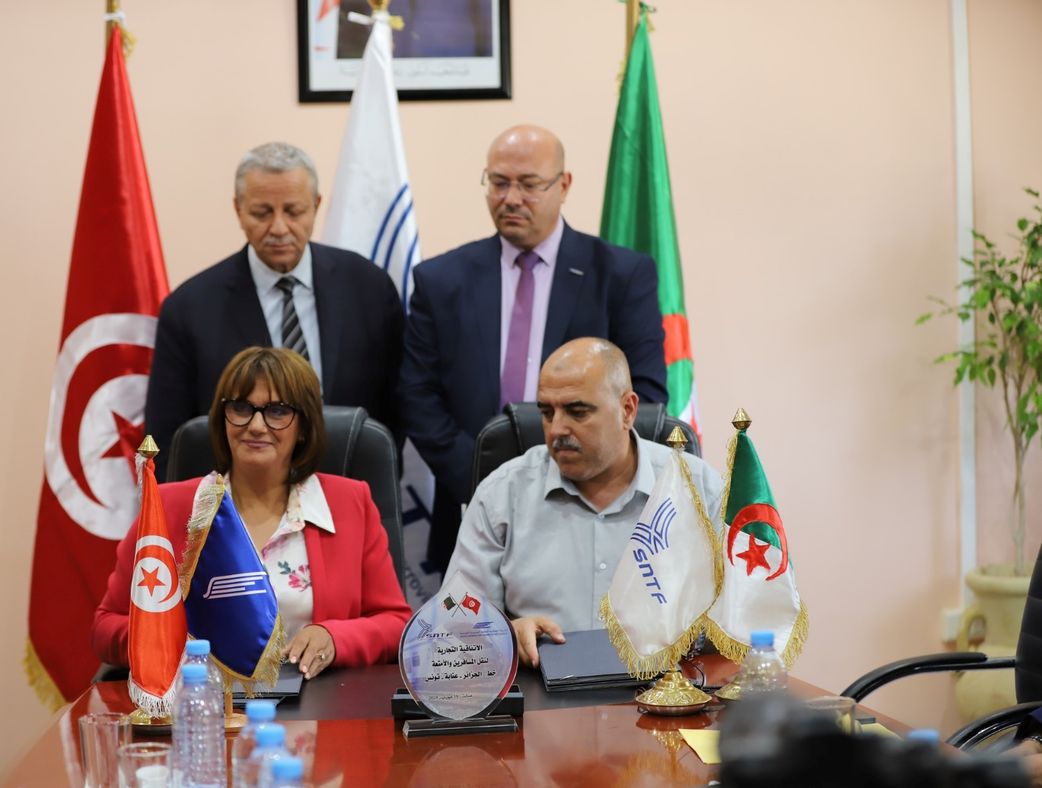

A Historical Overview:

The Tunisia-Algeria railway line (TA line) stands as a testament to the intertwined histories of Tunisia and Algeria. This vital transportation artery, with its roots in the 19th century, has significantly shaped the social and economic landscapes of both nations.

Construction commenced in phases, beginning with the Tunis-Tebourba segment and gradually extending to the border town of Ghardimaou. The final stretch, connecting to the Algerian network, was inaugurated in 1884. This strategic railway project, undertaken during the French colonial period, was primarily driven by economic and strategic imperatives. French companies, such as Batignolles and Bône-Guelma, played pivotal roles in the construction and operation of the line.

Passenger trains stopped running in December 1995 for security reasons. They briefly resumed service in July and August 2003 but were halted again due to technical issues with the locomotives.

Despite low volumes, goods transportation between Tunisia and Algeria continued uninterrupted until the COVID-19 pandemic halted it in 2019. Meanwhile, rail transport cooperation persisted through the Maghreb Railway Transport Committee. To further strengthen ties, the Tunisian and Algerian national railway companies signed a bilateral agreement on December 20, 2023, aiming to develop their networks and restore passenger and freight train services

The Tunis-Algeria Railway Line:
The Tunis-Algeria railway line (TA line) stretches 216.6 kilometers from the Tunisian capital to the Algerian border and approximately 357 kilometers to Annaba. Operating on a standard 1435 mm gauge, trains can reach a maximum speed of 130 km/h. The line includes 123 level crossings.
The train's composition
The train's composition includes a locomotive, four passenger coaches (two first-class and two second-class), a baggage coach, a service coach, and a
power coach.
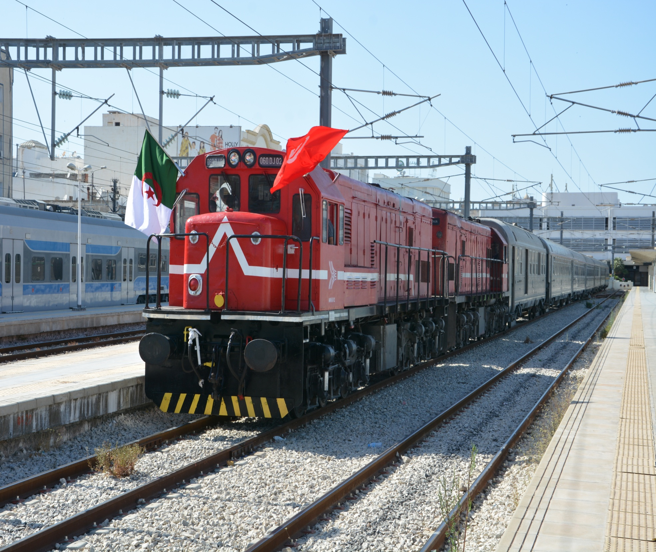
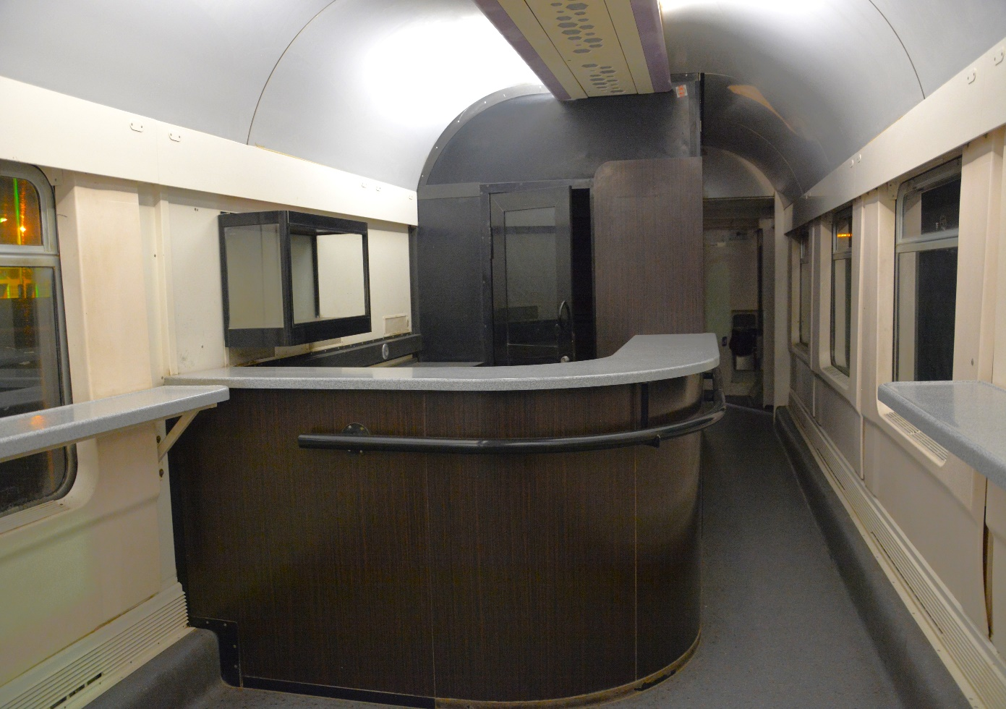 | 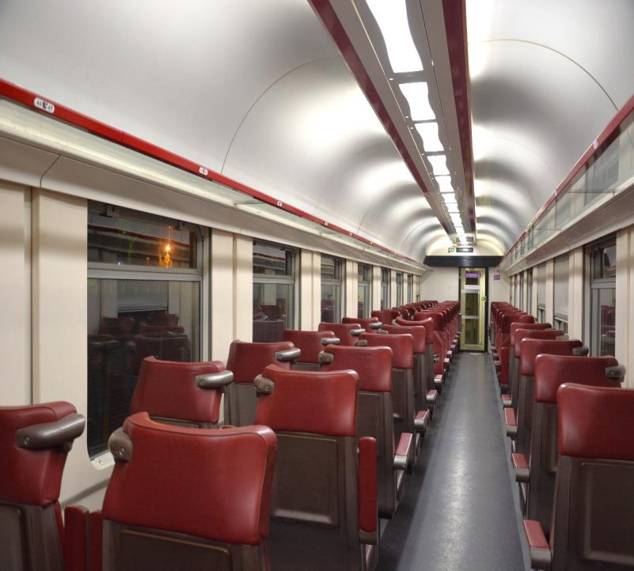
First-class passenger coaches
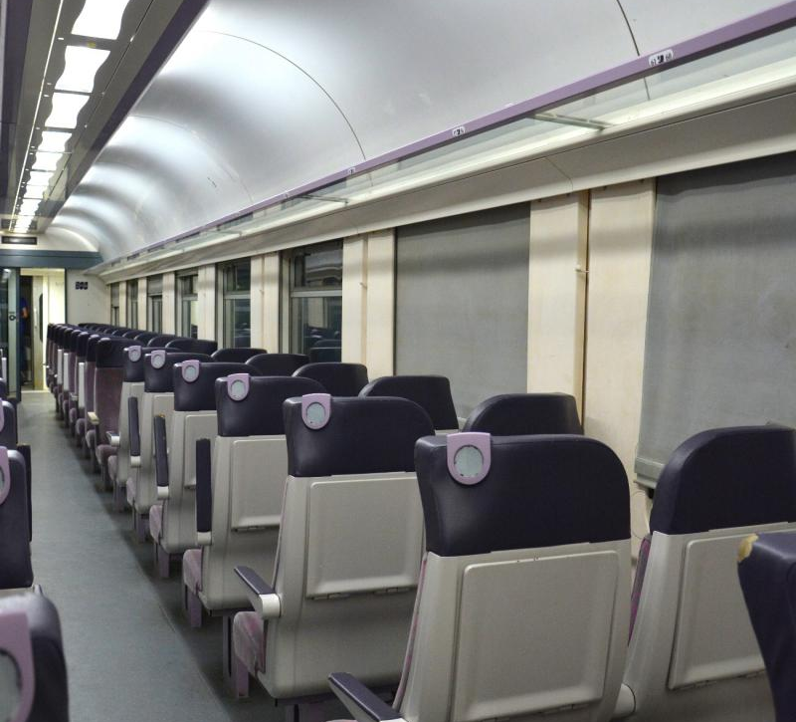 |  | 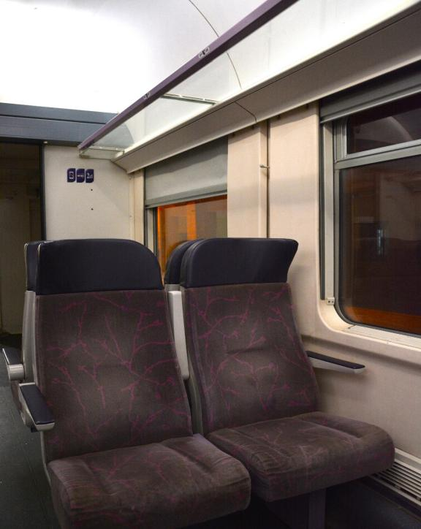
Second-class passenger coaches

Service frequency

Nationally, there are three daily round-trip train services between Tunis and Ghardimaou. As an initial step, an international train service is set to be introduced, operating three consecutive round trips per week between Tunis and Annaba with a one-day break.

Departure station and schedule
- Trains depart from Annaba to Tunis on Sundays, Tuesdays, and Thursdays.
- Trains depart from Tunis to Annaba on Mondays, Wednesdays, and Fridays.
- Saturdays are allocated for equipment maintenance at the National Railway Transport Company (SNTF) workshops.

Trial runs for passenger train services

- A historic milestone was reached on June 6, 2024, as the first trial run for passenger train service between Tunisia and Algeria was launched. The train, carrying a delegation from the Algerian National Railway Transport Company headed by General Director Adj BOUOUNI, successfully completed its journey from Annaba to Tunis, with passport and customs procedures conducted at the border station of Ghardimaou.

- The second trial passenger train between Tunisia and Algeria departed on July 15, 2024, with an Algerian railway delegation led by General Director Adj BOUOUNI. At the Ghardimaou station, Mr. Bououni met with his Tunisian counterpart Mr. Taoufik BOUFAIED and other officials, including the Governor of Jendouba and customs representatives.
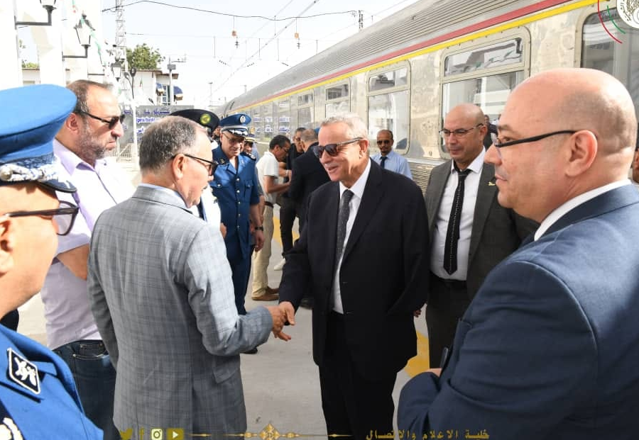

Inauguration date of passenger train operations between Tunisia and Algeria

The first commercial train services on the Tunis-Annaba line will start on August 11 from Tunis and on August 13 from Annaba. The modern trains will offer comfortable journeys for up to 300 passengers, with on-board dining and luggage facilities.

