Press release

Liebherr HVAC units for Etihad Rail high-speed trains

⸺
The HVAC units were installed in three high-speed trains manufactured in China for Etihad Rail in the United Arab Emirates
Liebherr’s HVAC technology enables comfortable travelling despite high temperatures outside
Liebherr Transportation Systems (China) Co., Ltd. has been commissioned to deliver and service heating, ventilation, and air-conditioning (HVAC) units for installation in three high-speed trains that will be operated by Etihad Rail.
Pinghu (China), July 2024 – Liebherr Transportation Systems (China) has supplied heating, ventilation, and air-conditioning systems (HVAC) units to Chinese rolling stock manufacturer CRRC Qingdao Sifang Co., Ltd. The saloon HVAC units were installed in three high-speed trains. The trains are operated by Etihad Rail, the national railway company of the United Arab Emirates (UAE), on UAE’s first national rail network.
With extreme outside temperatures of up to 60°C and occasional sand gusts, HVAC systems must work reliably for comfortable travelling by train. Liebherr's HVAC technology solution ensures a constant, agreeable climate on board and can keep the inside temperature in the saloons below 23°C - even with full passenger capacity. The HVAC saloon units offer for the pressure-protected high-speed train application an innovative redundancy concept and are equipped with a best-in-class air filtration system.
“We are honored to deepen our cooperation with customers by providing our HVAC solutions for their high-speed trains,” said Andreas Walter, General Manager of Liebherr Transportation Systems (China) Co., Ltd. "We are looking forward to being part of UAE's new rail network and providing services and support thanks to our local presence in the Middle East region."
About Liebherr-Aerospace & Transportation
Liebherr-Aerospace & Transportation SAS, headquartered in Toulouse (France), is one of 13 product segments of the Liebherr Group and a first-tier provider of on-board solutions in the aerospace and transportation industry, contributing to a more sustainable transport through innovative products, best in class services and performance excellence.
The aerospace product portfolio offered to civil and defense customers includes environmental control and thermal management systems, flight control and actuation systems, landing gears as well as on-board electronics. For rail vehicles of all kinds Liebherr offers heating, ventilation and air conditioning systems, passive and active hydraulic systems for braking, damping, axle steering and levelling. Furthermore, Liebherr serves the commercial vehicle market with trailer cooling systems.

About the Liebherr Group – 75 years of moving forward
The Liebherr Group is a family-run technology company with a highly diversified product programme. The company is one of the largest construction equipment manufacturers in the world. It also provides high-quality, user-oriented products and services in a wide range of other areas. The Liebherr Group includes over 150 companies across all continents. In 2023, it employed more than 50,000 staff and achieved combined revenues of over 14 billion euros. Liebherr was founded by Hans Liebherr in 1949 in the southern German town of Kirchdorf an der Iller. Since then, the employees have been pursuing the goal of achieving continuous technological innovation and bringing industry-leading solutions to its customers. Under the slogan ‘75 years of moving forward’, the Group celebrates its 75th anniversary in 2024.
Image
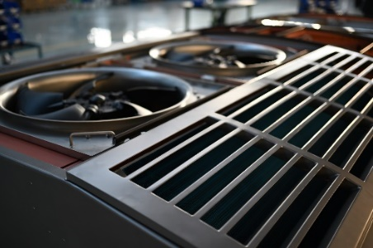
liebherr-hvac-unit-copyright-liebherr.jpg
Heating-, ventilation-, and air-conditioning- (HVAC) systems from Liebherr enable a reliable and constant indoor climate on board trains despite extreme outside temperatures. - © Liebherr

Contact
Ute Braam
Head of Corporate Communications
Phone: +49 8381 / 46 - 4403
E-mail: ute.braam@liebherr.com
Published by
Liebherr-Aerospace & Transportation SAS
Toulouse / France
www.liebherr.com

