Zaituni Nakonde Highlights The Central Corridor Transit Transport Facilitation Agency Progress At The AUC's Continental Workshop

Zaituni Nakonde, Director of Infrastructure Development at the Central Corridor Transit Transport Facilitation Agency (CCTTFA), spoke at the African Union Commission (AUC)’s Department of Infrastructure and Energy (IED) Continental Workshop. The event focused on the implementation of the Africa Integrated Railways Network (AIRN) and took place from 7th to 10th May 2024 in Dar es Salaam.

Zaituni highlighted the initiatives of the Central Corridor and the progress made on one of the AU’s - AIRN priority projects. The Central Corridor Transit Transport Facilitation Agency is comprised of seven countries: the Democratic Republic of Congo, Burundi, Malawi, Rwanda, Tanzania, Uganda and soon, Zambia. CCTTFA is a multilateral institution mandated to promote trade within the region through improvements in rail, road, water transport and port infrastructure development.

Focusing on the Standard Gauge Railway (SGR), Zaituni detailed the various links connecting from Dar es Salaam. The Central Corridor SGR starts at the port of Dar es Salaam and connects several key points. It is set to extend to Uganda at Mwanza, to Rwanda via Isaka and Rusumo, and continues to Kigali.

<MAP> 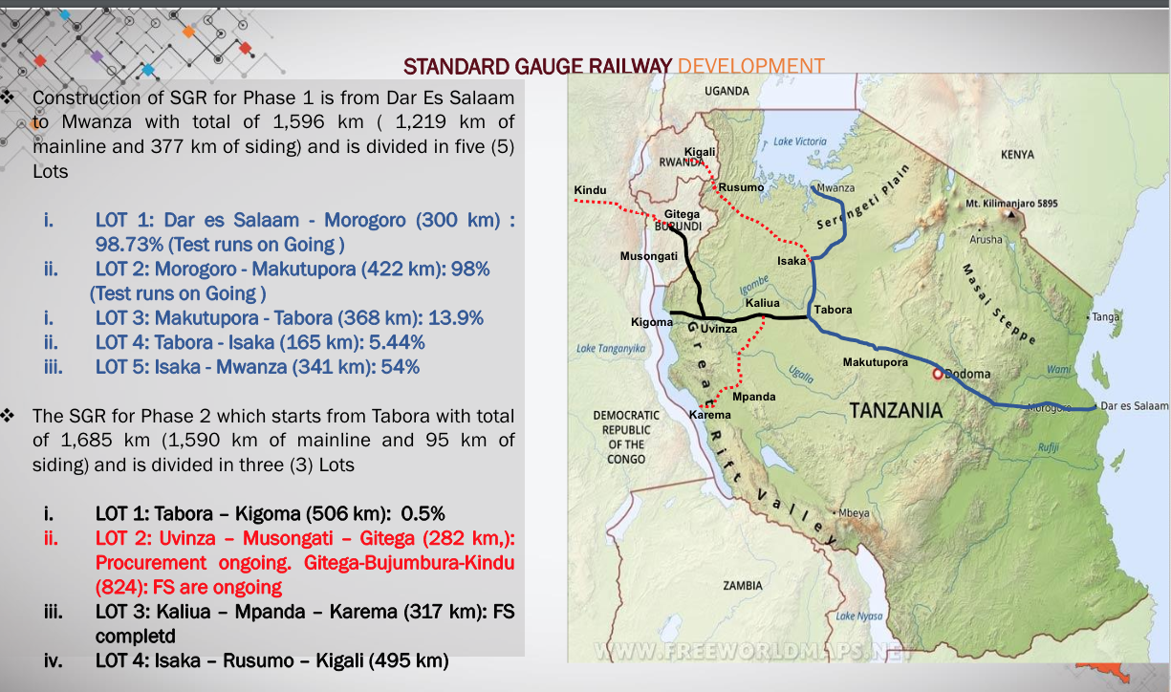

The blue lines on the map indicate ongoing construction, the black lines denote projects that have started but are not yet complete, and red lines represent projects still in the prefeasibility / study stage. Key sections such as Dar es Salaam to Dodoma, and then to Tabora and Mwanza, are already under construction and almost ready for commercial operations, The link from Tabora to Kigoma is also in progress. Additionally, the Mwanza to Gitega link, extending to Burundi, is nearing the finalisation of procurement and construction will soon commence . The Isaka to Rusumo to Kigali section is currently in feasibility studies.

The Makutupora to Tabora section is around 14% complete, while Tabora to Isaka is at 5%, and Isaka to Mwanza is 54% complete. The Uvinza to Musongati link's procurement is ongoing, and the Gitega to Kindu link, connecting to Congo, is in the feasibility study phase.
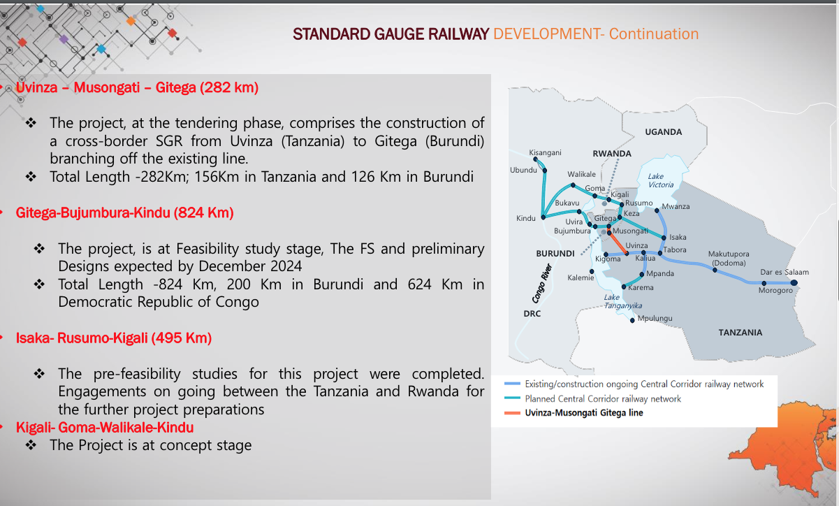

Zaituni also discussed the Central Corridor's initiatives to facilitate rail development in the region. These include coordinating member states for project preparation, which involves adequate studies and designs to attract funding. The African Development Bank has committed around $600 million to fund the Uvinza to Musongati link, with $500 million allocated for the Tanzanian side and $100 million for the Burundian side. To address the financing gap on the Burundian side, CCTTFA is partnering with GIZ and AUDA NEPAD through the SDM mechanism to attract green financing, leveraging climate rationale and carbon credit approaches.

CCTTFA is focusing on joint resource mobilisation to overcome the delays caused by individual countries mobilising resources independently. This approach has already been implemented with Tanzania and Burundi, and will continue with Burundi and the DRC. Engaging the private sector is also crucial, as governments alone cannot implement such large-scale projects. Private sector involvement is encouraged for first mile and last mile connectivity and rolling stock investment. Tanzania has opened its railway lines to private operators, allowing them to bring their wagons and transport cargo independently or for others at a fee.

Capacity building is another focus area, especially for countries like Rwanda and Burundi that are developing their rail networks for the first time. The Central Corridor has programmes for technical teams from these countries to gain experiential learning through attachments to ongoing construction projects.

Lastly, Zaituni mentioned an agreement to undertake a study that will guide member states on promoting a modal shift from road to rail. Currently, road transport dominates, but rail transport offers a more cost-effective and efficient alternative. This study aims to provide strategies to facilitate this transition, enhancing the overall transport infrastructure within the region.

SEO Meta Keywords: Zaituni Nakonde, Central Corridor Transit Transport Facilitation Agency, CCTTFA, African Union Commission, AUC, Department of Infrastructure and Energy, IED, Africa Integrated Railways Network, AIRN, rail infrastructure, regional connectivity, Standard Gauge Railway, SGR, Dar es Salaam, trade facilitation, transport infrastructure, green financing, modal shift
SEO Meta Page Description: Zaituni Nakonde of the Central Corridor Transit Transport Facilitation Agency highlights progress on the AU’s AIRN priority projects at the AUC’s Continental Workshop. Discover the advancements in rail, road, and port infrastructure across the Central Corridor.
SEO Title: Zaituni Nakonde Highlights Central Corridor Progress at AUC's Continental Workshop
Social Media: At the African Union Commission’s Department of Infrastructure and Energy Continental Workshop on the Africa Integrated Railways Network, Zaituni Nakonde from the Central Corridor Transit Transport Facilitation Agency (CCTTFA) discussed the progress of the Central Corridor's rail initiatives, including the Standard Gauge Railway and regional connectivity projects. Discover more about these developments here:
#RailwayDevelopment #CentralCorridor #RegionalConnectivity #rail #transport #railway #DRC #Burundi #Malawi #Rwanda #Tanzania #Uganda #Zambia

