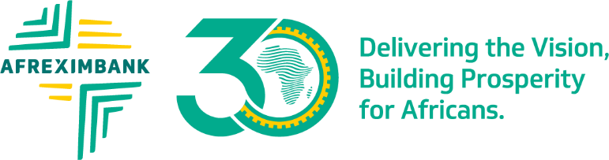
PRESS RELEASE
South Africa’s Progressive Business Forum honours Afreximbank board member Ronnie Ntuli with Lifetime Achievement Award
Mpumalanga Province, South Africa, 23 January 2024: – African Export-Import Bank (Afreximbank) board member Ronnie Ntuli has been awarded the Progressive Business Forum’s (PBF) prestigious Lifetime Achievement Award and was presented with the accolade at the Forum’s special celebrations marking three decades of democracy in South Africa.
The award, which was presented at the PBF’s inaugural “Show Up” awards ceremony, recognizes and celebrates individuals who have distinguished themselves in business, public service and, through their commercial, entrepreneurial and civic ventures. It also recognizes those who have acted to improve the common good and promote the wellbeing of others.
Mr Ntuli’s receipt of this award constitutes a recognition of his extraordinary contribution to the expansion of Southern Africa’s rail network and his application of engineering expertise to continental transport and logistics assets. Mr Ntuli founded and established the Thelo Group, as one of the continent’s eminent financiers of railway infrastructure and rolling stock, and the region’s most significant supporters of industrial development and high-value exports.
Further to these economic contributions, Ronnie has served his country and continent through extensive advisory work for a range of African Heads of State, where he has leveraged his unrivalled financial and engineering experience – as well as his background in Law – to help decision-makers devise policies and strategies to accelerate economic development and entrepreneurship.
Afreximbank President and Chairman of the Board of Directors, Prof. Benedict Oramah, commented;
I am delighted that my dear friend, and much-trusted advisor on Afreximbank’s Board, Mr. Ronnie Ntuli, has been recognized by the Progressive Business Forum for his decades of work on this continent. As both businessman and advisor, Ronnie’s contribution to our shared prosperity and development is quite simply incalculable. His counsel has been indispensable to the Bank, particularly as we navigated the challenges of implementing the African Continental Free Trade Area agreement.”
ENDS
About Afreximbank
African Export-Import Bank (Afreximbank) is a Pan-African multilateral financial institution mandated to finance and promote intra-and extra-African trade. For 30 years, the Bank has been deploying innovative structures to deliver financing solutions that support the transformation of the structure of Africa’s trade, accelerating industrialization and intra-regional trade, thereby boosting economic expansion in Africa. A stalwart supporter of the African Continental Free Trade Agreement (AfCFTA), Afreximbank has launched a Pan-African Payment and Settlement System (PAPSS) that was adopted by the African Union (AU) as the payment and settlement platform to underpin the implementation of the AfCFTA. Working with the AfCFTA Secretariat and the AU, the Bank is setting up a US$10 billion Adjustment Fund to support countries to effectively participate in the AfCFTA. At the end of September 2023, Afreximbank’s total assets and guarantees stood at over US$33.4 billion, and its shareholder funds amounted to US$5.8 billion. The Bank disbursed more than US$104 billion between 2016 and 2023. Afreximbank has investment grade ratings assigned by GCR (international scale) (A), Moody’s (Baa1), Japan Credit Rating Agency (JCR) (A-) and Fitch (BBB). Afreximbank has evolved into a group entity comprising the Bank, its impact fund subsidiary called the Fund for Export Development Africa (FEDA), and its insurance management subsidiary, AfrexInsure, (together, “the Group”). The Bank is headquartered in Cairo, Egypt.

