Espresso Week 3/2024

Transnet Freight Rail Tran Collision Near Elubana

Transnet Freight Rail (TFR) has reported that in the early hours of Sunday, 14 January 2024, two of its trains collided near Elubana, just outside Richards Bay on the KwaZulu-Natal North Coast. Teams from TFR were immediately dispatched to the site, and recovery operations are underway. Fortunately, no serious injuries were reported. Environmental experts are also present at the site to ensure that the recovery and clean-up operations adhere to environmental standards. An inquiry has been initiated to ascertain the cause of the incident.

In an updated statement, TFR says it expects rail service to resume before midnight on Thursday, 18 January on Line 2, and on Saturday, 20 January, on Line 1, subject to the weather conditions.

Uganda - Kawolo Concrete Sleeper Factory Temporarily Closes
On 13 December 2023, IMATHIA Construcción confirmed the temporary closure of the Kawolo Concrete Sleeper factory in Uganda, following the completion of the required sleepers for the refurbishment of the Kampala-Namanve-Mukonor Railway section. It is hoped that once the new contracts for the subsequent sections are issued, the factory will reopen.

Ethio-Djibouti Railway

30 December 2023, the Ethio-Djibouti Railway noted a significant milestone in its operations by transporting over 81,000 containers, indicating a robust increase in its cargo handling capacity since the start of services in 2018.

Egypt Project Update: Robeiky - 10th of Ramadan - Belbeis Railway Line Project

The Egyptian National Railways (ENR), in partnership with the Agence Française de Développement (AFD) and the European Bank for Reconstruction and Development (EBRD), is set to finance the development of the Robeiky - 10th of Ramadan - Belbeis Railway Line Project. This project involves the supply and installation of railway tracks, signalling, and telecommunication systems. View the opportunity by logging into our premium subscribers platform.

Opportunity: MULTINATIONAL BURUNDI/ZAMBIA TRANSPORT CORRIDOR DEVELOPMENT PROJECT – premium subscribers only.

United Manganese of Kalahari

United Manganese of Kalahari (UMK) has announced that, in response to the worsening market conditions, it will reduce the production of manganese ore and concomitant to that, the sale of its ore products, for the time being. The company will return to normalised outputs when the market recovers. The temporary slowdown in production and sales will have no impact on the company’s employee body. UMK is the fourth largest producer of Manganese in South Africa with operations in the Northern Cape province.

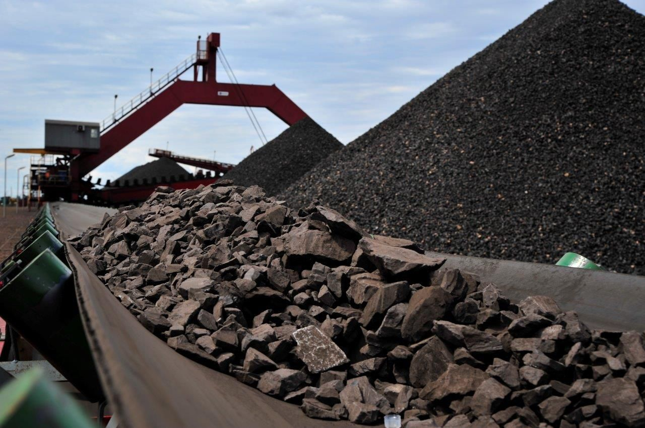

Mauritius Metro Express incident at St Louis Station

On Thursday, 11 January 2024, an incident occurred at the Metro Express St Louis Station wherein a glass pane from the roof canopy cracked and fell onto the platform area below. The precise cause of the glass pane's fall onto the platform is currently under investigation.

Fortunately, no passengers were on the platform at that time, and nobody was harmed.

Necessary actions have been initiated to temporarily cover the broken part of the canopy using polycarbonate sheets. The permanent replacement with a new glass pane will be undertaken once the materials reach Mauritius in February 2024.

As a precautionary measure, technical teams have conducted surveys at all stations to inspect the glass infrastructure and take necessary actions if required.

( Craig – I sent these pics via whatsapp)

Construction Of Beitbridge Bulawayo Railway West Nicholson Rail Siding

Raymond Shoniwa, General Manager at Beitbridge Bulawayo Railway (BBR), reported that the construction of the BBR West Nicholson Rail Siding is nearing completion, with civil works now 95% complete. Track works are set to commence, aiming for completion by 21 January 2024.

The West Nicholson Siding, situated 170 km from the Beitbridge border, will serve as a dry port for handling Lithium and Chrome cargo bound for the ports of Maputo, Richards Bay and Durban.

The initial target is to handle 50,000 tonnes per month. This siding will specifically manage cargo from the Sandawana Lithium Mine, with destinations including Maputo and Durban. The first mile of transport will be by road.

Currently, the mine produces 200,000 tonnes of raw lithium ore per month. The target for the commencement of operations is 1 February.

Social Media: Beitbridge Bulawayo Railway’s West Nicholson #Rail Siding is almost done at 95% completion. Set to handle 50K tonnes of Lithium & Chrome monthly, operations start 1st February. #BBR #Railway #Transportation #Mining

China Civil Engineering Construction Corporation (CCECC) – Nigeria

In December 2023, the China Civil Engineering Construction Corporation (CCECC) completed the track laying from Port Harcourt to Aba on the Nigeria Railway Corporation’s (NRC) Eastern Narrow-Gauge Railway project.

The Nigeria Eastern Narrow-Gauge Railway, extending over 2,044.1 kilometres, connects Harcourt Port, the nation's second-largest port, with the northern city of Maiduguri. This line passes through 12 states and numerous principal cities in the eastern region. As a key element of Nigeria's railway network, it is poised to considerably enhance the connectivity between local railways, ports, and cities. – Photo Credit China Civil Engineering Construction Corporation (CCECC) – website.

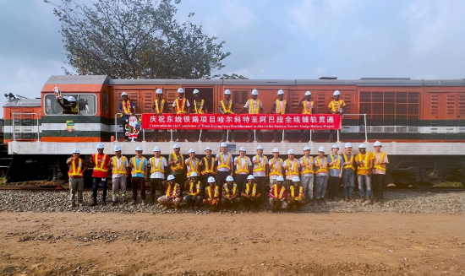

International: ATAC S.p.A. has awarded CAF the framework contract for the supply of the new tram fleet

ATAC S.p.A. has awarded CAF the framework contract for the supply of the new tram fleet for the Italian capital city. The contract specifically covers the design and manufacture of 40
trams, train maintenance for 5 years and the associated fleet spares. There is also an option
to increase the number of units in the project by a further 81, taking the total to 121. The base
contract is worth in excess of €130m, which could grow to in excess of €400m should the
customer make use of all the options provided for in the contract.

ATAC S.p.A., the public transport concessionaire for the metropolitan area of Rome, which is wholly owned by the City Council of Rome, is the largest urban transport company in Italy and one of the leading European players. In addition to the tram network, it also controls Rome's three metro lines, the suburban train, as well as the urban bus and trolleybus lines that
provide the backbone of the city's transport network.

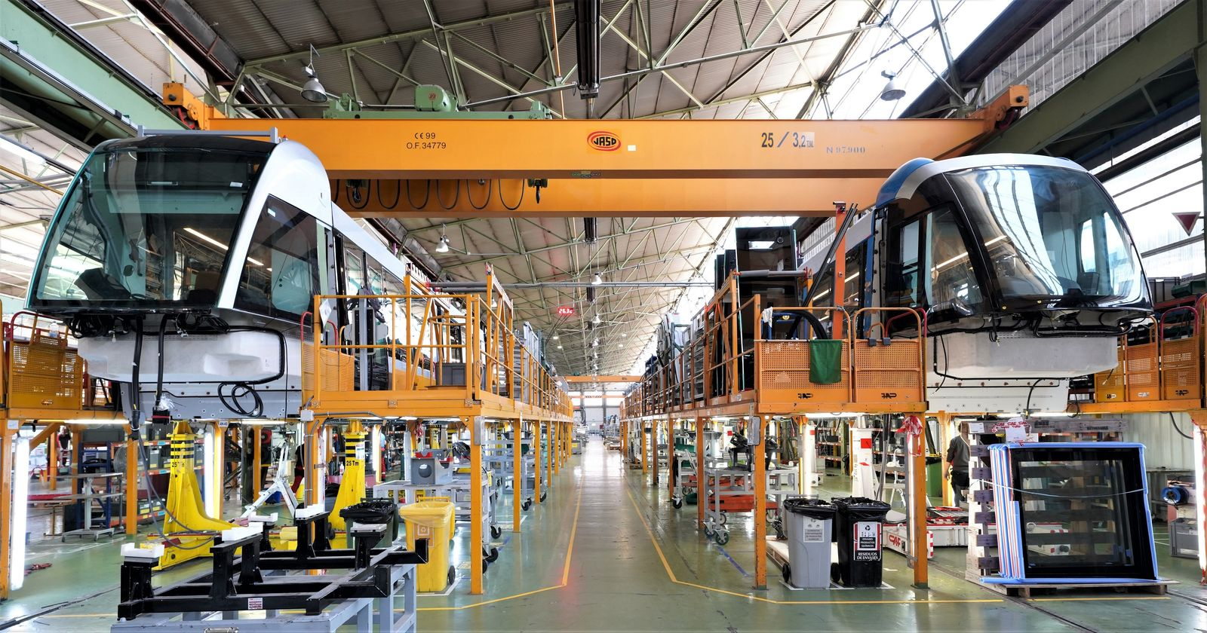

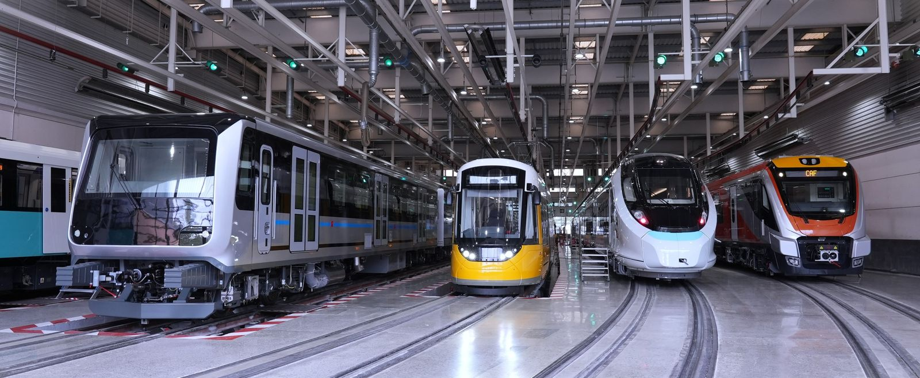

LAMATA And Police Join Forces To Secure Upcoming Red Line Rail Project

The Lagos State Police Command and the Lagos Metropolitan Area Transport Authority (LAMATA) are collaborating to ensure the security of lives and property, particularly in relation to the upcoming LRMT - Red Line Rail project.

This partnership comes in response to recent protest actions that caused significant damage to transport infrastructure. By strengthening their security ties, they aim to provide a robust security presence along the rail corridor. This effort is crucial for protecting passengers and infrastructure, thereby ensuring that Lagos State can offer a safe and efficient transportation alternative for commuters. The Red Line Rail project is expected to begin operations in the first quarter of 2024.

Mauritania: SNIM Surpasses 14 Million Tonnes In Annual Sales

On 30 December 2023, SNIM announced that it had achieved a historic milestone by surpassing 14 million tonnes in annual sales. The success can be attributed to SNIM's strategic program and the dedication of its workforce.

SNIM's strategy aims to bring operational transformation and contribute significantly to the national economy. Historically, SNIM has played a vital role, contributing 22% to state budget revenues, 9% to the gross national product, and accounting for 32% of export volume in 2022.

CRRC’s Qishuyan Company successfully ships four CDA5A1 locomotives to Guinea

In December 2023, CRRC’s Qishuyan Company noted that they had successfully shipped four CDA5A1 locomotives to Guinea. The locomotives are for the Guinea-Dasheng Railway.

The locomotive purchase deal was signed between CRRC Qishuyan Company and Win Alliance Guinea Railway Company on 30 June 2023.

