Competition and the Railways

By Rowland Ataguba

In the Wealth of Nations, Adam Smith expounds the theory of the “Invisible Hand” which suggests that if every consumer is permitted to freely choose what to buy and every producer allowed to freely choose what to sell and the mode of production, the market will settle on a product distribution and prices that are beneficial to all the individual members of a given community, and thus to the wider population. The rationale being that self-interest will motivate participants to beneficial behavior. Efficient modes of production will be adopted so as to maximize profits. Lower prices will be charged so as to undercut competitors. Investors will seek to maximize returns by investing in those industries in the greatest demand, and withdraw from less rewarding activities.

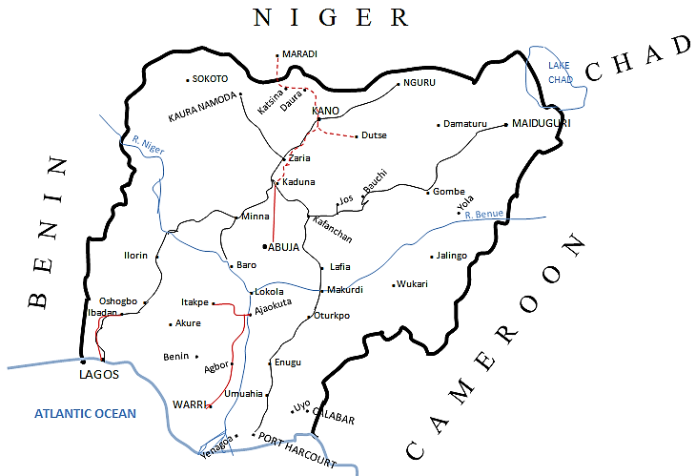

KEY
Narrow gauge lines
Standard gauge lines
Standard gauge lines under construction

Nigeria’s Existing Railway Network

Inhabitants of a poor country for instance, will be willing to work for lower wages and entrepreneurs from richer countries will build their plants in poorer countries and reap huge rewards. As they however raise demand for labour, wages will rise. As the new producers also become consumers for inputs, local businesses will employ more people in order to meet the growing demand. As this process continues, labour prices will rise to a point of diminishing returns, at which it is no longer advantageous for the foreign entrepreneur to invest in the formerly poor country. Such a mechanism thus enables the local economy to function independently.

The market mechanism therefore engenders competition between producers for business and consumers for products. Movements in price then become the determinant signal of what is consumed and produced. Competition therefore enables innovation as producers seek to differentiate their products for competitive advantage and obtain efficiencies to reduce costs and undercut the competition. Society benefits in the long run as consumers pay an optimal price for what they consume, knowledge is dispersed and modern productive skills are acquired. Producers expand capacity and employment rises to fill the gap which creates new effective consumers.
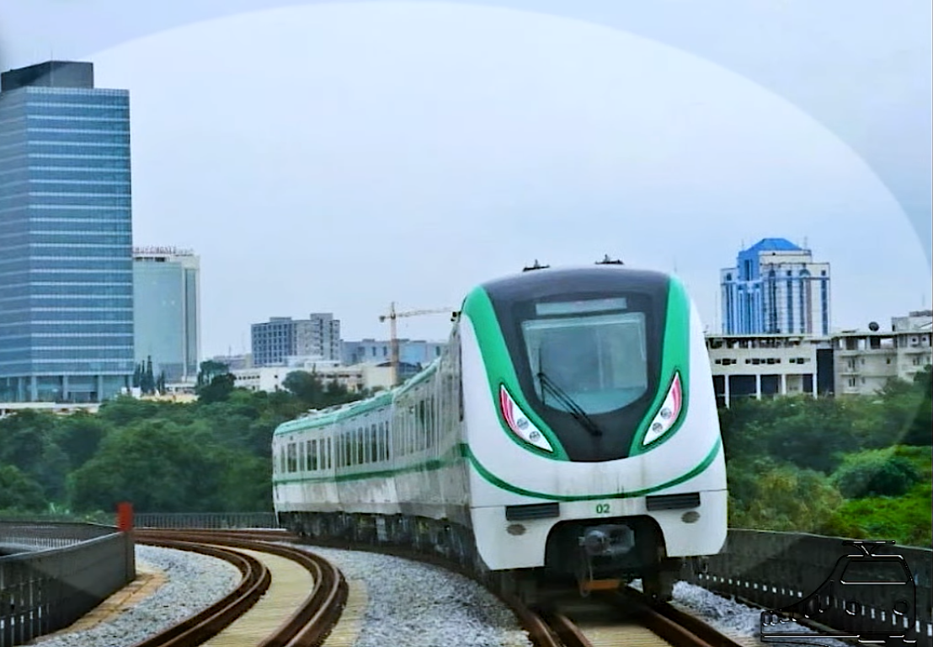

Abuja-Kaduna Train

Unfettered competition may however give rise to negative consequences in what Nobel economics laureate, Joseph Stiglitz, describes as “externalities”, some of which can be pervasive. Externalities are actions of individuals which impact negatively on others for which the affected are uncompensated and the perpetrators do not pay. Environmental pollution or greenhouse gases can be such instances. Further, unregulated competition may breed anticompetitive behaviour (or cheating) which affects the integrity of the market. Governments thus have a number of roles to play. They are expected to enforce property rights and contracts and to regulate markets on the one hand and act as a buyer of last resort to prevent systemic failure on the other. The raging debate is about finding the right balance between markets and government (and the third “sector”—non-governmental non-profit organizations.) Markets and government complement each other and finding the balance while acknowledging that it may differ from time to time and place to place is the key challenge of modern times.

The railways as with most network industries in developed economies have historically been managed by governments though their origins may have been in the private sector. As the nature of government inhibits innovation and competition, most of these railway industries lost market share as competition from the mostly privately produced alternatives such as road, air and water transport took market share. Increasingly, governments have been unable to fund the substantial investments required to maintain efficient railway services and have looked to the private sector to invest capital and infuse best management practices.

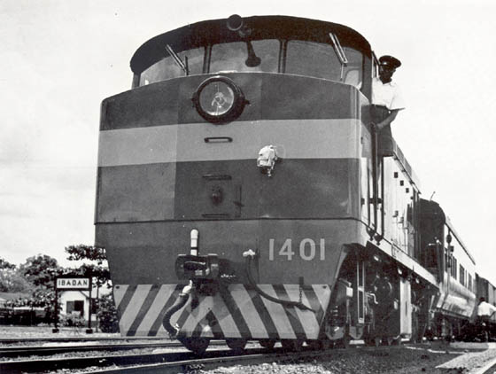

Train at Ibadan Station in 1963

In many ways the Railways are not like any other industry, not even any other network industry. Their technology has changed much slower than say telecoms. Further, they face greater economies of density than the electricity industry. Investment and operational decisions also require much closer co-ordination on the railways than in air transport for instance. The coordination of different operations is significantly more complex than in other networks, and importantly, there are more substitutes in the lives of consumers than the services of other network industries.

Two types of competition models have emerged on the railways: Competition for the market where firms bid to provide monopoly services, and on-track competition, where firms compete to provide identical services to consumers on an open access basis.

Generically, a railway system consists of two essential components. The first being the infrastructure which comprises of the permanent way, stations, depots, signalling and telecoms, etc. while the second component is the operation of the rail services including the rolling stock consisting of locomotives and wagons.

Where one organization is responsible for both infrastructure and operations, we talk of vertical integration, and vertical separation (or disintegration) where the components are managed by different organizations. We talk about horizontal integration, when one organization provides all the services produced on a particular network such as freight and passenger services, and horizontal separation where these services are provided by separate organizations. Horizontal separation may also apply where the network is broken up into geographical units and different firms provide services (which may be integrated or separated) on each of these geographical units of the network. For instance, a firm may provide freight and passenger services on the Warri–Ajaokuta line while being responsible for the infrastructure. Whereas a different firm may provide similar (or even di-similar) services on the Lagos-Kano line.

Similarly, a third firm may do likewise on the Port-Harcourt-Maiduguri line. We would then describe the Nigerian railway network in such circumstances, as a horizontally separated network. Separation may still be taken many steps further. For instance, one or more firms may provide freight services on each route (line), while another or separate firms may provide passenger services on each route. This would still be horizontal separation. Finally, we have partial separation (or disintegration) where a vertically integrated infrastructure manager (usually publicly owned) competes in the downstream market against other usually private, operators.
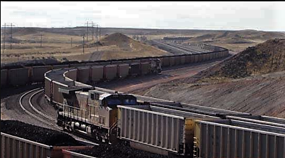

Movement of bulk minerals. Railway at its best

Various countries have tried different approaches to bringing about competition to their railways. In Europe, the impetus was provided by the European Commission directive 91-440 requiring separate accounting for infrastructure and operations. This led to a trend towards institutional separation across the continent. Whereas in the USA, the vertical integration model has remained effective because of the very competitive environment between different modes of transport. In South America, integrated and separated systems sit side by side. Ditto in Australia, Asia and the Far East. In India, the railways remain a nationalised and vertically integrated service.

The unique characteristics of any network in terms of traffic density, economies of scope and scale, competitive intensity between modes of transportation etc. would influence the appropriate approach. One key consideration is what has been described as the “hold-up” problem or bottlenecks, in investment decision making. In a vertically separated network for instance, how do you prevent an infrastructure manager from holding up the operator who requires investment in the infrastructure so that he can improve his service such as providing say, a high speed train service while maintaining conventional services for other operators? Conversely, how do you encourage a vertically integrated operator to invest in assets other than that which is specified in his concession agreement?

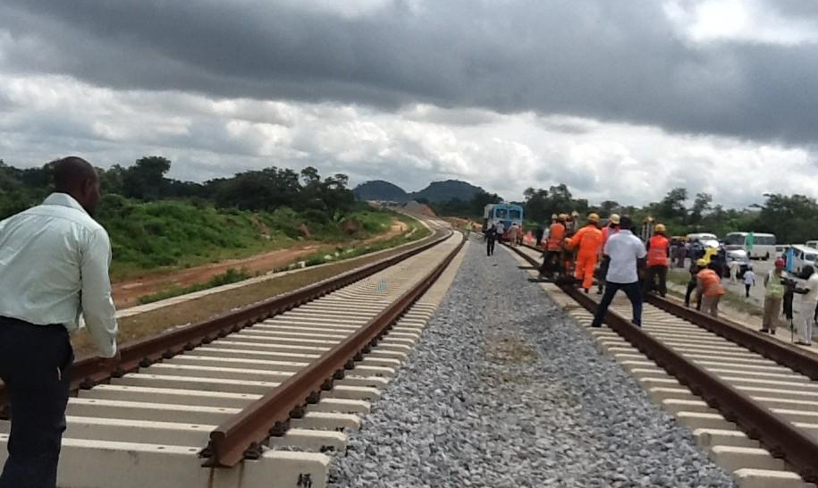

Developing the permanent way on Kaduna - Abuja

The essential benefit of a vertically separated rail industry is that it takes out the 'sunk cost'/natural monopoly element of rail provision and creates a more contestable environment. This enables a lowering of barriers to entry and levels the playing field somewhat, especially in regulating competition and transparency in subsidizing various transport modes. In doing so however, several problems are indirectly created. An increase in transaction costs between the infrastructure manager and train operators, potential abuse of the infrastructure manager’s monopoly position, problems of co-ordination of investment in track infrastructure and rolling stock, potential problems in obtaining finance for new infrastructure investment, concerns in coordinating infrastructure maintenance and the responsibility for resultant delays, and train operators’ loss of control over a vital input into their businesses, infrastructure.

While a strong regulator, and close co-operation, can resolve the problems of monopoly abuse and investment co-ordination, the increase in transaction costs and train operators’ lack of control over the infrastructure appear unavoidable. The infrastructure manager would need to quickly develop a reputation for delivering reliable and fast service otherwise potential concessionaires would be wary to be dependent on an inefficient organization for the provision of their infrastructure and will price in substantial contingencies to manage the risk.

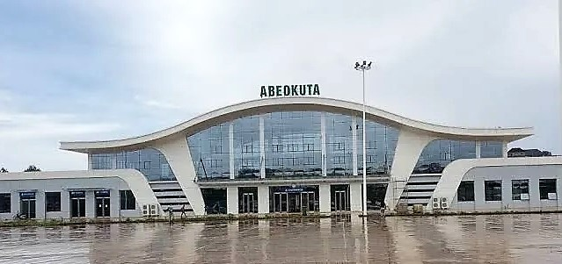

Wole Soyinka Train Station, Abeokuta

Studies have shown that rail operations exhibit constant average costs. Horizontal separation therefore does not reduce a rail operator's ability to produce at minimum cost. An examination of economies of scale, density and scope using a translog model of operating costs to test for such economies for 15 western European railways concludes that in terms of economies of scale with respect to operating costs, the smallest operators exhibit increasing returns, the medium sized operators exhibit constant returns and the largest operators exhibit decreasing returns. In terms of returns to density, with the exception of the most heavily used systems (Switzerland and the Netherlands), all the operators exhibit increasing returns. Such results suggest that the size of a network does matter. The perceived wisdom is that to minimise operating costs, the optimal railway should consist of a network of around 4,000 km of track, run 120 million train km per annum, giving it a density of around 30,000 train km per line km per annum. An interesting import of the research is however that some branch lines may be operated efficiently as free standing units.

The provision of complementary services is another issue raised by horizontal separation. The problem arises because of the interdependency between different operators in terms of providing and attracting passengers. Long haul operators for instance may rely to a great extent upon local/regional operators to feed passengers into their operations. The actions of a local operator will therefore have implications for a long haul operator's revenue. A further problem arises when a service is unprofitable for an independent operator but could be profitable for a more integrated operator. Such a problem may be overcome if train operators are willing to pay compensation to another operator to run a potentially uneconomical service. However, such an approach requires detailed information and could become very complex if there are other third party operators involved. To an extent this problem is negated by the regulator providing compensation, in the form of subsidy, to train operators for a specified level of service. However, a single integrated organization would be better aware of such interdependencies to identify all possible optimal arrangements quickly and with minimum information costs.

Further issues raised by 'horizontal separation', which could be termed as 'network benefits' include, co-ordination and integration of timetables and publicity, through ticketing and inter availability of tickets.

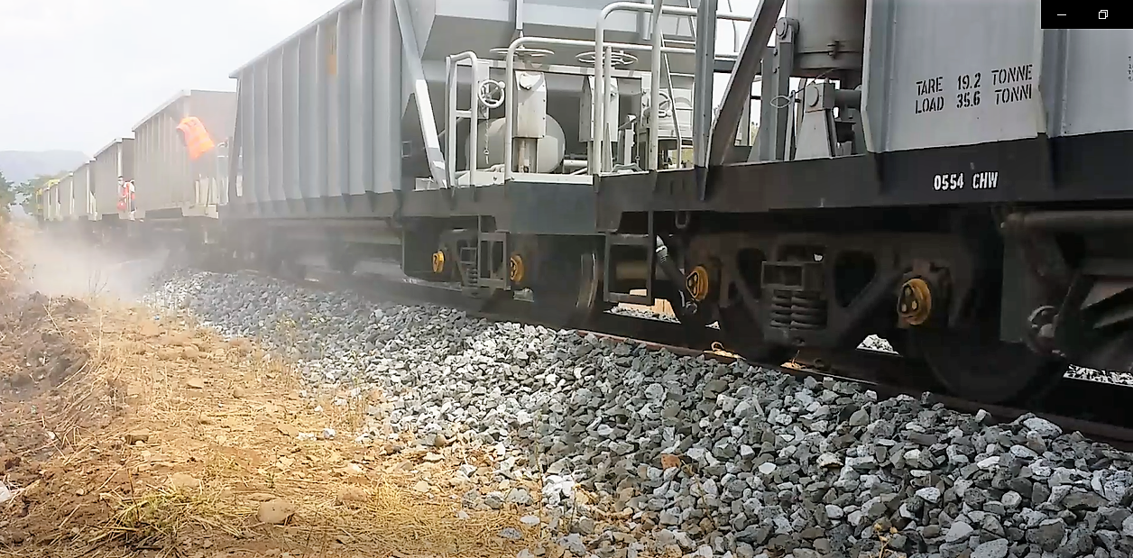

Rehabilitating Port Harcourt – Maiduguri legacy railway

Producing a national coordinated and integrated timetable should be the responsibility of the infrastructure manager. Timetables are of major importance to rail passengers, especially for trips involving interchange with two or more train operators. The timetable should have the characteristics of allowing passengers to plan their journeys with a large degree of certainty and minimise passenger interchange time. With horizontal separation, the complexities of producing such a timetable are increased, especially given 'open access'. There may also be some confusion on the allocation mechanism for train paths. For instance, will such allocation follow a commercial or a social criteria? Whom will have priority, long haul or local operators? A further issue is the publicity of the national timetable, the infrastructure manager should have the responsibility to produce it but the costs of publicizing it may dampen its fervour. However, the internet has reduced the costs of publicizing timetabling but responsibility for errors can be a dis-incentive.

The limited experience available has shown though that vertical separation will not on its own provide significant improvements in performance and efficiency of railway systems. When combined with horizontal separation however, the improvements have been significant such as we have seen in Sweden.

In the final analysis, the promotion of competition for its sake should not be a per se objective but simply as a means for enabling efficiency and equity. In essence, it should not go against the simple rules of fairness, but seek to protect investments of all firms in specific assets, especially intangible assets such as intellectual property. If the assets exhibit the characteristics of a public good with decreasing average costs of use, it is useful to ensure that opening them up to competition does not discourage investment in the assets in the first place.

** Excerpts from the seminal series “Modelling the Nigerian Railways” by Rowland Ataguba who is a member of the NRC Unbundling Committee of the Federal Ministry of Transportation in Nigeria. He is author of “Memorandum for a Constitution Amendment to Transfer Railways from the Exclusive Legislative List to the Concurrent List” which led to the passage of the Constitution Amendment 5th Alteration (No. 16) Act effecting the transfer. He is CEO of Bethlehem Rail Infrastructure Limited, a dedicated project management consultancy in London.

