Press information

London Cable Liner® featuring Liebherr technology

⸺
Uniform heating, ventilation and air-conditioning (HVAC) standard for different vehicle platforms
Low weight and low energy consumption
Space-saving, roof-mounted air-conditioning system using modular design
Liebherr’s MACS 8.0 air-conditioning systems ensure comfort in the DART Cable Liner® made by Doppelmayr Cable Car and carvatech.
Korneuburg, (Austria), May 2023 – Liebherr-Transportation Systems was commissioned in 2019 by the Austrian company carvatech Karosserie- und Kabinenbau GmbH to supply 24 air-conditioning systems for two cable-drawn, fully automated Cable Liner® public transit systems from Doppelmayr Cable Car GmbH.
Following the successful launch of Liebherr’s universal MACS 8.0 units (Modular Air-Conditioning Systems), commercial passenger operations of the Luton DART (Direct Air to Rail Transit) began this year. The units ensure reliable air-conditioning and therefore a high level of comfort for the passengers of the Cable Liner®.
The two-kilometer route runs from Luton Airport Parkway station to London Luton Airport. Up to 2,720 passengers per hour and direction can be accommodated for.
Dirk Junghans, Managing Director of Liebherr-Transportation Systems GmbH & Co KG, states, “The successful implementation of this project underlines our leading position as a supplier of air-conditioning systems for transport applications, and we are now equipping the Cable Liner® with our standard MACS 8.0 product for the first time.”
“The MACS 8.0 air-conditioning system is an essential component feature of the Cable Liner® cars we produce and makes a valuable contribution to the comfort of passengers”, confirms Michael Leithinger, Technical Manager at carvatech.
The Chameleon
The MACS 8.0 air-conditioning system from Liebherr is characterized by its versatility and adaptability when used in various transport applications. Its design is particularly of interest due to high system availability, lowest weight and low energy consumption. The individual modules are identical in their “plug-and-play” design and performance, so they can be easily installed and combined depending on the cooling and heating requirements for the passenger compartment or driver’s cab. In this way, the product is perfectly suited for both new vehicles or for retrofitting existing vehicles with an air-conditioning system.
About Liebherr-Transportation Systems
Liebherr-Transportation Systems provides the rail transport sector with heating, ventilation and air-conditioning (HVAC) systems for driver cabs and the passenger area, various cooling systems for e-mobility applications without overhead lines, thermal management systems for electronics, as well as hydraulic drive systems, bogie steering systems, dampers and equipment for hydraulic load leveling for rail vehicles of all types. Liebherr looks back on many years of experience in the development, manufacture and maintenance of these technical systems and offers comprehensive support throughout the entire product life cycle. The company continuously invests in research and development to provide new generations of different transport system solutions for its customers.
Liebherr-Transportation Systems operates three production facilities in Korneuburg (Austria), Marica (Bulgaria) and Pinghu (China). In addition to its own sales and service centers, the Transportation Systems product segment utilizes the Liebherr Group's advanced and unique technologies as well as its development and service facilities located around the globe. Thanks to the company's global presence, Liebherr-Transportation Systems is there for its customers - anytime, anywhere.
About the Liebherr Group
The Liebherr Group is a family-run technology company with a highly diversified product portfolio. The company is one of the largest construction equipment manufacturers in the world. It also provides high-quality and user-oriented products and services in a wide range of other areas. The Liebherr Group includes over 140 companies across all continents. In 2022, it employed more than 51,000 staff and achieved combined revenues of over 12.5 billion euros. Liebherr was founded in Kirchdorf an der Iller in Southern Germany in 1949. Since then, the employees have been pursuing the goal of achieving continuous technological innovation, and bringing industry-leading solutions to its customers.
Images
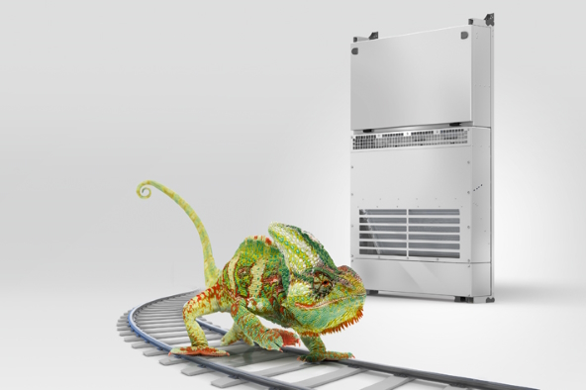
liebherr-MACS-8-0-copyright-liebherr.jpg
The Chameleon amongst air-conditioning systems: MACS 8.0 – © Liebherr
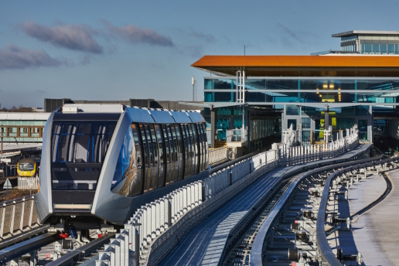
cable-liner-2E5A1672-coypyright-carvatech.jpg
Cable Liner® DART by Doppelmayr Cable Car - © Doppelmayr

Contact
Ute Braam
Corporate Communication
Tel.: +49 8381 / 46 - 4403
E-Mail: ute.braam@liebherr.com
Published by
Liebherr-Aerospace & Transportation SAS
Toulouse / France
www.liebherr.com

