PRE-ANNOUNCEMENT OF COMPANY NAME CHANGE

D&M Rail Construction, a leading railway construction, and maintenance company based in Namibia since 2009, has announced that the company has undergone a name change.
The name change, along with strategic, structure, and management changes undergone over the past 12 months within the group, aligns with the overall group vision of being the railway and infrastructure firm of choice, not only in Namibia but regionally.
D&M Rail Construction will henceforth be known and operate as Afri-Track Railway Construction.
During the week of 5 to 9 June 2023, the Afri-Track Group will be launched in Windhoek to showcase its expanded portfolio and footprint across the SADC region.
Established offices already exist in Namibia, South Africa, Botswana, and Zambia.
During the launch, guest speaker and well-known railway engineering specialist, Professor Hannes Gräbe, will give talks on modern approaches to the railway industry at large.
Afri-Track Group Holdings is a diverse, multi-disciplinary firm invested in the growth and sustainability of the communities and economies in which we operate.

Our drive to establish specialized entities that form part of our eco-system to enable
us to offer a wide range of solutions in infrastructure, mining, renewable energy,
agriculture and communication sectors.

The merging of professionals, in their respective industries, and enthusiasm across
the board has resulted in a vehicle for sustainable business that can deliver complex solutions.

We are committed to play our part in the efforts to reduce the carbon footprint in the industries we serve.

Watch this space for more information.
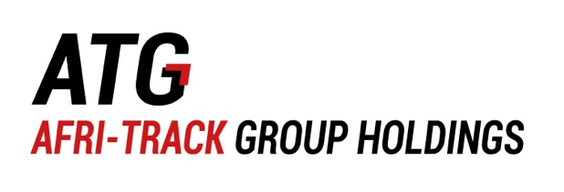
For an insight of the company please visit www.afri-track.com
