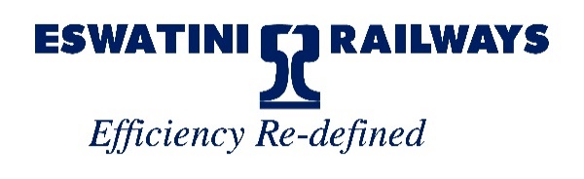

UPDATE ON ESWATINI RAIL LINK (ESRL) PROJECT
The Eswatini Rail Link project team has spearheaded the project to reach significant milestones on its growth path. This is a joint effort between Transnet Freight Rail and Eswatini Railways. The project is currently at Project Affected People resettlement phase. Many resettlements alternative sites have been prepared for the construction phase which started in March 2023 in Eswatini.

This inter-railway initiative between Transnet Freight Rail (South Africa) and Eswatini Railways entails the construction of a 146 km new railway line/link from Lothair, South Africa to Sidvokodvo, Eswatini and the revamping of adjacent existing lines to align and provide support to the new link.

The project is intended to be a rail and road traffic congestion solution based on a realistic and achievable system capacity. The target is to accommodate trains of up to 26 tons/axle, 2.5km long/200 wagons trains and a capacity of 12 trains each way per day, in line with infrastructure interventions, thereby creating a dedicated General Freight Business Corridor for Transnet, while providing necessary additional capacity for Eswatini Railways. This growth in capacity adds to the current capacity of 12 trains of 81 wagons per day each way on the current ESR Komatipoort-Golela Line that will double the traffic volumes. Consequently, the Eswatini Rail Link project will enable added capacity on general freight business.

The Image below shows the Eswatini Railways System Map with added details of the new Eswatini Rail Link Project.

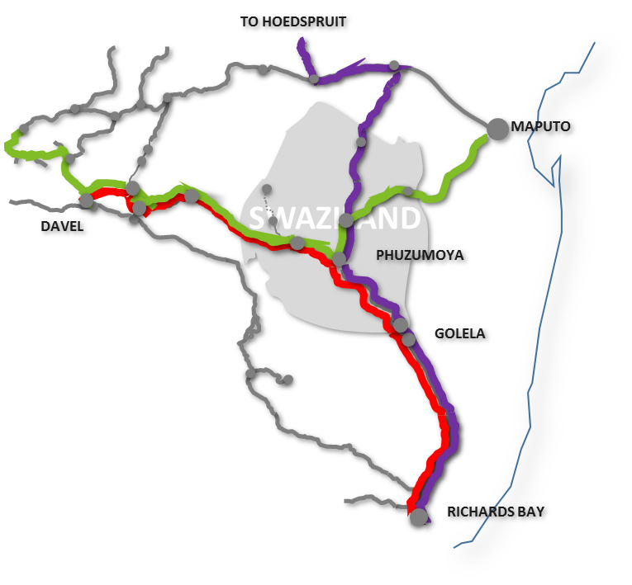

Recent developments in both the Kingdom of Eswatini and the Republic of South Africa include the following:

- The signing of dossiers by project affected people.
- Acquisition of land in South Africa and Eswatini is in progress.
- In Eswatini, the clearing of land and construction of homesteads for the ongoing resettlements is underway.
- Ongoing procurement process for building contractors.
- A structure at grass roots level comprising of affected people is in place to address all resettlement issues. A participatory process to manage the relocation of homes is ongoing.
- A robust consultative process with traditional authorities and other stakeholders is ongoing.
- Complete adherence to regulatory and statutory requirements lies at the core of the entire project.

- The Government of the Kingdom of Eswatini is in full support of the project as evidenced by the availing of resources for the relocation process.

- In Eswatini, the resettlement of project affected people is underway. On the 13th April the Honourable Minister of Public Works and Transport of the Kingdom of Eswatini toured household resettlement sites where construction has started. The photo below was taken during the tour.

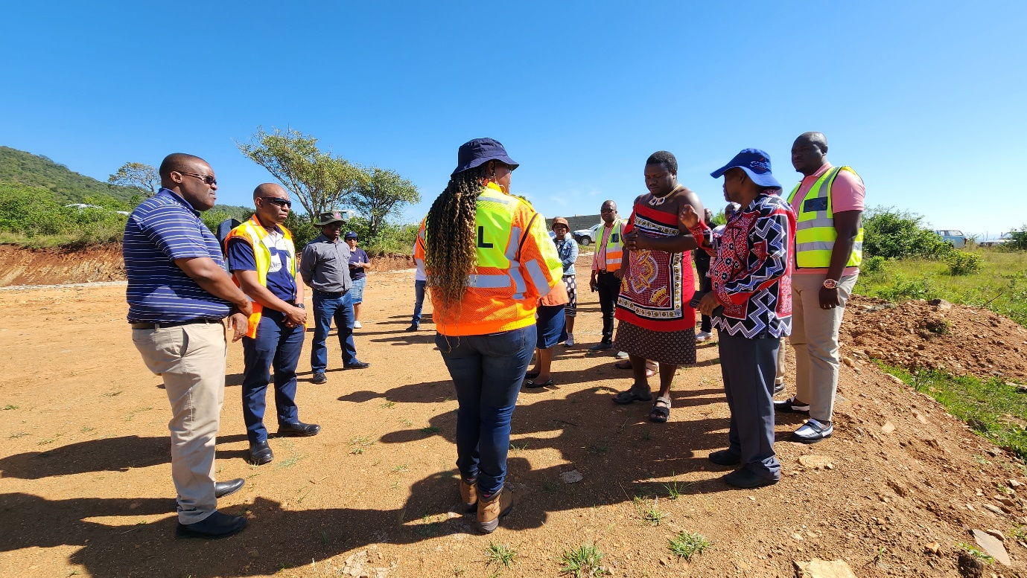

Opportunities:
This project has already created opportunities on both sides of the boarder. Emaswati companies have participated at business level in undertaking some of the work and general Emaswati have benefitted in direct short-term employment.
- Will create jobs in line with the stage of the project.
- Will create business opportunities, facilitate skills transfer and training.
- Will unlock mining opportunities.
- Will give rise to Corporate Social Investment initiatives.
- Boost both Eswatini and RSA economies.
- Regional integration

Construction
Construction will start once the resettlement process is complete, the process to source a financier of the project is underway.

For more information contact
Sandile Dlamini (Acting Project Director): +268 7802 2286
Senanile Mayabane (Project Manager): +268 76185359

