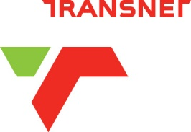

TRANSNET ENGINEERING SEEKS PARTNER TO ESTABLISH ROLLING STOCK LEASING COMPANY

[Johannesburg, 3 April 2023] Transnet Engineering (TE), an Operating Division of Transnet SOC Ltd. (Transnet) is seeking a partner to establish a leasing company, in response to domestic and regional demand, which will lease rolling stock - including wagons and locomotives - to third party operators on the rail network.
The establishment of a leasing company is in response to – inter alia - the policy directive for rail reform, and aims to create a more enabling environment by lowering barriers to entry for new Train Operating Companies (TOCs) who will be utilising available slots on the network in line with the regime for third party access.
The leasing company will also lease port equipment locally and on the continent. It is an effective and sustainable global trend among global rail and port operators, and aims to grow and diversify Transnet Engineering’s revenue sources, while driving demand for its core business of manufacturing, re-manufacturing and engineering services.
To this end, TE has approached the market to submit responses to its Request for Proposals, issued on xx April 2023, and closing on xx xx 2023.
The scope of the partnership includes the following:
- Acquisition of capital assets.​
- Developing rolling stock and port equipment leasing capabilities in South Africa. ​
- Leasing rolling stock assets in South Africa and to markets outside of South Africa.
- Development of business opportunities.​
Ensuring that the capital assets are well maintained and available for leasing to customers.
.
ENDS

Issued on behalf of Transnet SOC Ltd

